Fourth Sunday of Easter

May 11, 2025

**PRELUDE**  *My God, I Love Thee*

**WELCOME TO WESTMINSTER & PRAYER OF INVOCATION**

**† CALL TO WORSHIP**  *from Psalm 27*

Leader: The Lord is my light and my salvation; whom shall I fear?

**People: The Lord is the strength of my life; of whom shall I be afraid?**

Leader: One thing have I desired of the Lord, that will I seek after;

**People: That I may dwell in the house of the Lord all the days of my life,**

**to behold the beauty of the Lord.**

Leader: For in the time of trouble he shall hide me in his shelter: in the secret

of his tabernacle shall he hide me; he shall set me up upon a rock.

**People: And now shall my head be lifted up above my enemies round**

**about me: therefore will I offer in his tabernacle sacrifices of**

**joy; I will sing, yea, I will sing praises unto the Lord.**

**Choral INTroit** *Psalm 100*

**† HYMN OF PRAISE**  *Jesus Shall Reign Where’er the Sun (#231)*

**SCRIPTURE READING** Psalm 4

**PRAYER OF CONFESSION**

God of glory, you sent Jesus among us as the light of the world, to reveal your love for all people. We confess that our sin and pride hide the brightness of your light. We turn away from the poor; we ignore cries for justice; we do not strive for peace; we do not share your truth. In your mercy, cleanse us of our sin, and pour out the gifts of your Spirit, that, forgiven and renewed, we may show forth your glory shining in the face of Jesus Christ. It is in His name that we pray...

*(Prayers of silent confession)*

**ASSURANCE OF FORGIVENESS**

**† Doxology**

**Sacrament of Baptism**

Gabriel Thomas Simpson

Son of Alec and Mary Simpson

**† Hymn** *I Am for You*

**JUNIOR CHURCH**

**CHURCH FAMILY HIGHLIGHTS**

**OFFERING**

**PRAYERS OF THE PEOPLE & THE LORD’S PRAYER**

Our Father, who art in heaven, hallowed be thy name. Thy kingdom come; thy will be done on earth as it is in heaven. Give us this day our daily bread and forgive us our debts, as we forgive our debtors. Lead us not into temptation but deliver us from the evil one. For thine is the kingdom, and the power, and the glory, forever and ever. AMEN.

**SCRIPTURE READING** 1 John 1:1-2:2

**SERMON**  *The Fellowship of the Light*

Rev. Owen Stepp

**† AFFIRMATION OF FAITH** Apostles’ Creed

I believe in God the Father Almighty; Maker of heaven and earth.

And in Jesus Christ His only Son, our Lord; who was conceived by the Holy Ghost, born of the Virgin Mary, suffered under Pontius Pilate, was crucified, dead, and buried; he descended into hell; the third day he rose again from the dead; he ascended into heaven and sitteth on the right hand of God the Father Almighty; from thence he shall come to judge the quick and the dead.

I believe in the Holy Ghost, the holy catholic Church, the communion of saints, the forgiveness of sins, the resurrection of the body, and the life everlasting. AMEN.

**The Lord’s Supper**

**Invitation**

**Words of Institution**

**Prayer of Thanksgiving**

**Communion songs**  *Come, Risen Lord*

*Let Us Break Bread Together (#323)*

*We invite all who have put their faith in Christ and been baptized to come to the Lord’s Table. We believe that children should be instructed on the meaning of the sacrament prior to receiving the Supper. Whether you are receiving communion or not we invite everyone to come forward and receive a blessing from the pastors during this time.*

**† HYMNS OF RESPONSE** *Jesus, the Light of the World*

**† BENEDICTION**

**POSTLUDE** *Let the Whole Creation Cry*

*Our Prayer Team will be available to pray with anyone in the Chapel following the service.*

Welcome to Westminster Presbyterian Church

*We are thankful you are here worshiping with us. We invite you to register your attendance with us today on the friendship pad found at the end of the pew.*

**Upcoming Events**

*Sign up here for all upcoming events.*

**

**WPC Newsletter**

*Please use the QR code to see our newsletter.*



**Worship Supplement**

101 Colville Road, Charlotte, NC 28207 | 704-376-0751 | westminstercharlotte.org

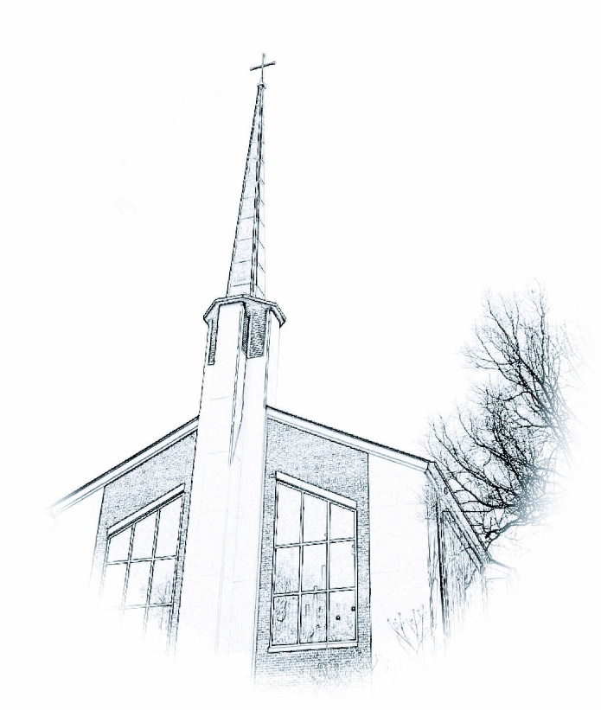

*Inviting people to life in Christ…*

*lived together…*

*for the sake of others.*