First Sunday of Advent
November 30 , 2025

PRELUDE Let All Mortal Flesh Keep Silence
WELCOME TO WESTMINSTER Elder Scott McClintock
PRAYER OF INVOCATION
† CALL TO WORSHIP
Leader: In You alone we put our hope, God the Father, our Creator.
People: You give all good things, seen and unseen.
Leader: In You alone we put our hope, God the Son, our Savior and
Redeemer.
People: You died for our sins and rose again.
Leader: In You alone we put our hope, God the Spirit, our Intercessor,
and Comforter.
People: You inspire us to sing, pray and praise.
Leader: We worship you Father, Son and Holy Spirit.
People: In You alone we put our hope.
† HYMNS OF PRAISE Come Thou Long Expected Jesus (#124)
Living Hope
Lighting of the Advent Candle Leighton Ford and Linda Simpson
SCRIPTURE READING Isaiah 2:1-5
PRAYER OF CONFESSION
Lord Jesus, We confess that we are quick to put our hope in people and things other than you. We are often more driven by our pride than by our faith in you and your kingdom. We place our hope in our own strength, intelligence and wealth rather than in you. Forgive us for our misplaced trust in the things of this world that will never satisfy and will always fail us. Root out our sin and renew our hope in you during this season of Advent. In our savior’s name we pray…
(Prayers of silent confession)
ASSURANCE OF FORGIVENESS
† DOXOLOGY

JUNIOR CHURCH
OFFERING
Song of Preparation Behold The Lamb O God
† SCRIPTURE READING Matthew 24:36-44
SERMON Expectant Hope
Rev. Owen Stepp
Pastoral Prayer & tHE Lord’s Prayer
Our Father, who art in heaven, hallowed be thy name. Thy kingdom come; thy will be done on earth as it is in heaven. Give us this day our daily bread and forgive us our debts, as we forgive our debtors. Lead us not into temptation but deliver us from the evil one. For thine is the kingdom, and the power, and the glory, forever and ever. AMEN.
† AFFIRMATION OF FAITH Heidelberg Catechism
Q. #1 What is your only comfort in life and in death?
A. That I am not my own, but belong body and soul, in life and in death to my faithful Savior, Jesus Christ. He has fully paid for all my sins with his precious blood, and has set me free from the tyranny of the devil. He also watches over me in such a way that not a hair can fall from my head without the will of my Father in heaven; in fact, all things must work together for my salvation. Because I belong to him, Christ, by his Holy Spirit, assures me of eternal life and makes me wholeheartedly willing and ready from now on to live for him.
† HYMN OF RESPONSE O Lord, How Shall I Meet You
† BENEDICTION
POSTLUDE The King Shall Come When the Morning Dawns
Our Prayer Team will be available to pray with anyone in the Chapel following the service

Welcome to Westminster Presbyterian Church
We are thankful you are here worshiping with us. We invite you to register your attendance with us today on the friendship pad found at the end of the pew.

Upcoming Events
Tonight – 5:00pm - Sundays in Song – Carols, Cookies and Cocoa in Beard Hall. Bring your favorite cookies to share.
Dec 3rd – Dec 17th – 6:00pm - Soup, Story and Sacrament. Join us in Beard Hall for a hearty soup, a Christmas story and receive the Lord’s Supper.
Dec 6th – 10:00am – Women’s Christmas Brunch. Join us for fellowship and brunch at Jordan Horstman’s home.
Dec 7th – Congregational Meeting following 11am service.
Dec 7th – 5:00pm – Third Third Christmas Social. The vision is to engage, encourage and equip those entering the “third season” of life. (60+ years).
Dec 7th – 5:00pm – Youth Christmas Party at the Boyce’s home.
Dec 14th – 12:15pm – Second Sunday Lunch – Join us following the 11am service for fellowship.
Dec 14th – 5:00pm – Service of Lessons and Carols – Invite friends, family, and neighbors for a special evening of scripture and music. Stay for light refreshments and more music afterward.

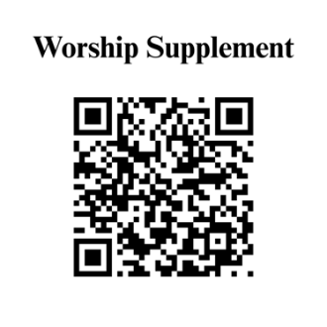

Find out more about Westminster by scanning the codes below with your phone’s camera:


101 Colville Road, Charlotte, NC 28207 | 704-376-0751 | westminstercharlotte.org

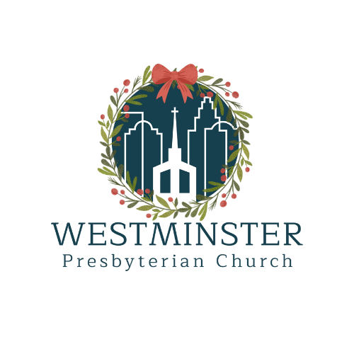

Inviting people to life in Christ…
lived together…
for the sake of others.

