Twenty-Second Sunday after Pentecost
November 9 , 2025

PRELUDE Brethren, We Have Met to Worship
Come, Thou Fount of Every Blessing
WELCOME TO WESTMINSTER Elder Kelly Boyce
PRAYER OF INVOCATION
† CALL TO WORSHIP Psalm 100:4
Leader: The psalmist says: “Enter His gates with thanksgiving and His
courts with praise.” Gratitude opens us. Fear closes us. Today we
choose gratitude.
People: We give thanks, for God is here. Christ is with us. The Spirit is
at work.
Leader: Let us stand ready to notice God’s invitation, to speak with
grace, and to walk in wisdom toward those around us.
All : We worship the God who leads us on The Way. Thanks be to
God.
† HYMNS OF PRAISE Come Thou Fount of Every Blessing (#2)
Yahweh, the Lord (Psalm 145)
SCRIPTURE READING Matthew 5:13-16
PRAYER OF CONFESSION
Gracious God, we confess that we often move through our days distracted and unaware of Your presence. You call us to pray with alert minds and thankful hearts, but we live hurried, anxious, and preoccupied. You open doors for grace and conversation, yet we are silent or speak without kindness.
Forgive us for missed moments, closed hearts, and careless words. Awaken us to Your Holy Spirit at work around us. Restore us by Your loving-kindness. Give us grateful hearts, attentive eyes, and words seasoned with grace. In Christ we pray.
(Prayers of silent confession)
ASSURANCE OF FORGIVENESS
† DOXOLOGY

JUNIOR CHURCH
OFFERING
HYMN OF PREPARATION Yet Not I, but Through Christ in Me
SCRIPTURE READING Colossians 4:2-6
SERMON Devote Yourself to Prayer
Tamara Park Walters
Pastoral Prayer & tHE Lord’s Prayer
Our Father, who art in heaven, hallowed be thy name. Thy kingdom come; thy will be done on earth as it is in heaven. Give us this day our daily bread and forgive us our debts, as we forgive our debtors. Lead us not into temptation but deliver us from the evil one. For thine is the kingdom, and the power, and the glory, forever and ever. AMEN.
† AFFIRMATION OF FAITH Apostles’ Creed

I believe in God the Father Almighty; Maker of heaven and earth.

And in Jesus Christ His only Son, our Lord; who was conceived by the Holy Ghost, born of the Virgin Mary, suffered under Pontius Pilate, was crucified, dead, and buried; he descended into hell; the third day he rose again from the dead; he ascended into heaven and sitteth on the right hand of God the Father Almighty; from thence he shall come to judge the quick and the dead.

I believe in the Holy Ghost, the holy catholic Church, the communion of saints, the forgiveness of sins, the resurrection of the body, and the life everlasting. AMEN.
† HYMN OF RESPONSE May Jesus Christ Be Praised (#87)
† BENEDICTION
POSTLUDE March from “Scipio”
Our Prayer Team will be available to pray with anyone in the Chapel following the service

Welcome to Westminster Presbyterian Church
We are thankful you are here worshiping with us. We invite you to register your attendance with us today on the friendship pad found at the end of the pew.

Upcoming Events

Nov 16th – 12:15pm - Second Sunday Lunch - Join us for fellowship right after the 11am service.
Nov 16th – 12:15pm - Welcome to Westminster - Join us to learn more about Westminster and how you can get connected.
Nov 16th - 5:30pm - Third Third Gathering - The vision is to engage, encourage and equip those entering the “third season” of life. (60+years).
Nov 23rd – 12:15pm – The Hanging of the Greens. Join us to help decorate the church for the Advent Season.
Nov 30th – 5:00pm - Sundays in Song – Carols, Cookies and Cocoa

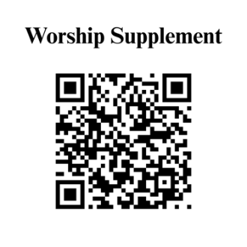

Find out more about Westminster by scanning the codes below with your phone’s camera:


101 Colville Road, Charlotte, NC 28207 | 704-376-0751 | westminstercharlotte.org

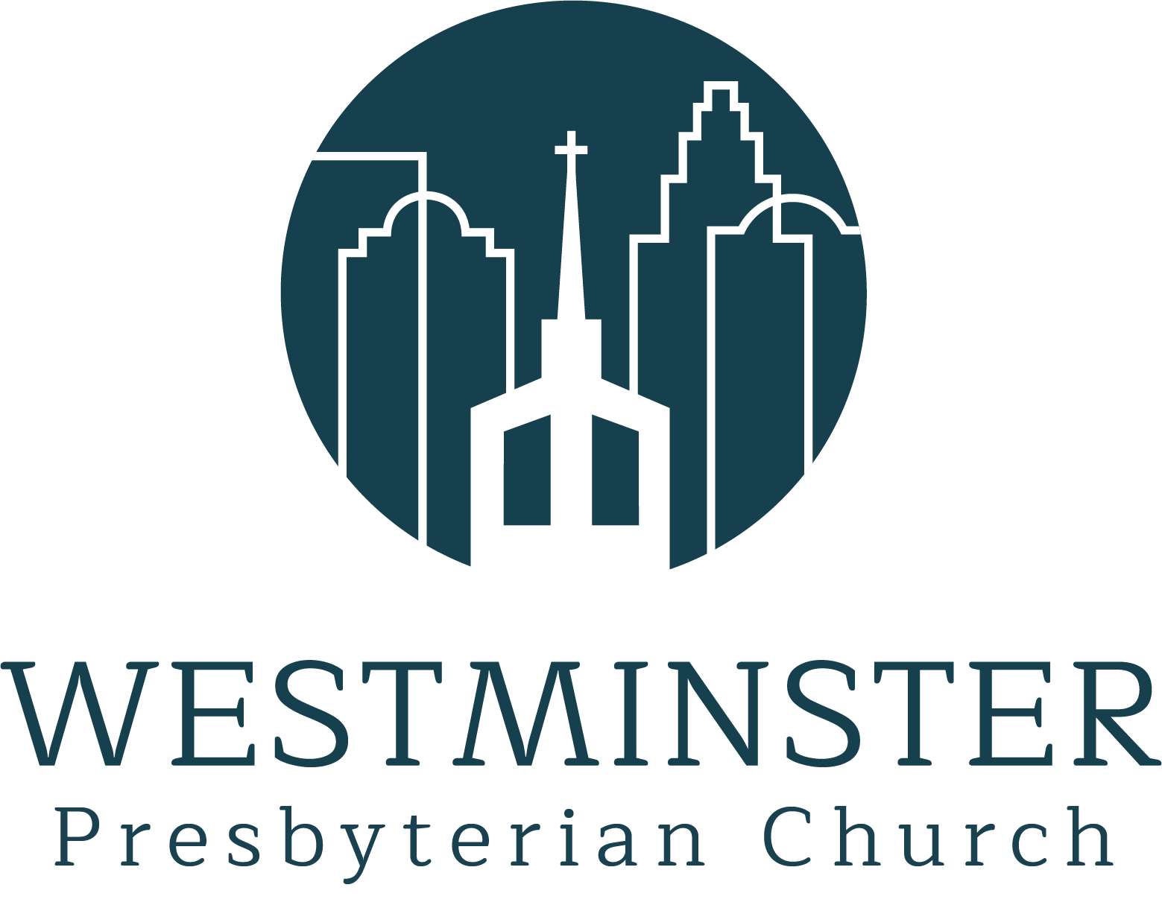

Inviting people to life in Christ…
lived together…
for the sake of others.

