Eighteenth Sunday after Pentecost
October 12, 2025

PRELUDE Prelude in C
WELCOME TO WESTMINSTER Elder Dennis Chen
PRAYER OF INVOCATION
† CALL TO WORSHIP from Psalm 33
Leader: By the word of the Lord the heavens were made,
People: And by the breath of his mouth all their host.
Leader: He gathers the waters of the sea as a heap;
People: He puts the deeps in storehouses.
Leader: Let all the earth fear the Lord;
People: Let all the inhabitants of the world stand in awe of him!
Leader: For he spoke, and it came to be;
People: He commanded, and it stood firm.
Leader: The counsel of the Lord stands forever,
People: The plans of his heart to all generations.
Leader: In him our hearts rejoice, for we trust in his holy name.
People: May your unfailing love be with us, Lord, even as we put our
hope in you.
† HYMNS OF PRAISE Bless The Lord, O My Soul (Psalm 103)
In Christ Alone
SCRIPTURE READING Matthew 5:13-16
PRAYER OF CONFESSION
Our Father, you have saved us by your grace, but our gratitude has been lacking. Rather than trusting you, we trust the gifts you have given us. We confess that our misplaced hope and reliance is on money, intelligence, and resources. Help us hope in you, trust in you, and grow in our likeness to Jesus. In Jesus’ name we pray...
(Prayers of silent confession)

ASSURANCE OF FORGIVENESS

† DOXOLOGY
JUNIOR CHURCH
OFFERING
† HYMN OF PREPARATION Hymn Of The Holy Spirit
Pastoral Prayer & tHE Lord’s Prayer
Our Father, who art in heaven, hallowed be thy name. Thy kingdom come; thy will be done on earth as it is in heaven. Give us this day our daily bread and forgive us our debts, as we forgive our debtors. Lead us not into temptation but deliver us from the evil one. For thine is the kingdom, and the power, and the glory, forever and ever. AMEN.
SCRIPTURE READING 2 Peter 1:3-11
SERMON I Believe. Now What?
Rev. Owen Stepp
† AFFIRMATION OF FAITH Heidelberg Catechism
Q. #86 Since we have been delivered from our misery by grace through Christ without any merit of our own, why then should we do good works?
A. Because Christ, having redeemed us by his blood, is also restoring us by his Spirit into his image, so that with our whole lives we may show that we are thankful to God for his benefits, so that he may be praised through us, so that we may be assured of our faith by its fruits, and so that by our godly living our neighbors may be won over to Christ.
† HYMN OF RESPONSE Come All Christians, Be Committed (#455)
† BENEDICTION
POSTLUDE The Rejoicing
Our Prayer Team will be available to pray with anyone in the Chapel following the service.

Welcome to Westminster Presbyterian Church
We are thankful you are here worshiping with us. We invite you to register your attendance with us today on the friendship pad found at the end of the pew.

Upcoming Events

Sept 24th – Nov 5th – 5:30pm - Westminster Wednesday Dinner and program featuring a video series “Practicing the Way” with John Mark Comer.

Oct 12th – 12:15pm - Second Sunday Lunch - Join us for fellowship right after the 11am service.

Oct 19th - 5:30pm - Third Third Gathering - The vision is to engage, encourage and equip those entering the “third season” of life. (60+years).

Oct 25th – 26th - Worship Workshop Weekend with Mike O’Brien. Find out more on the website.

Oct 26th – 5:00pm - Sundays in Song – Worship Circle Night led by WPC Youth.

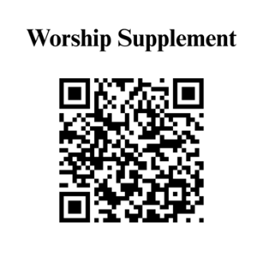

Find out more about Westminster by scanning the codes below with your phone’s camera:


101 Colville Road, Charlotte, NC 28207 | 704-376-0751 | westminstercharlotte.org

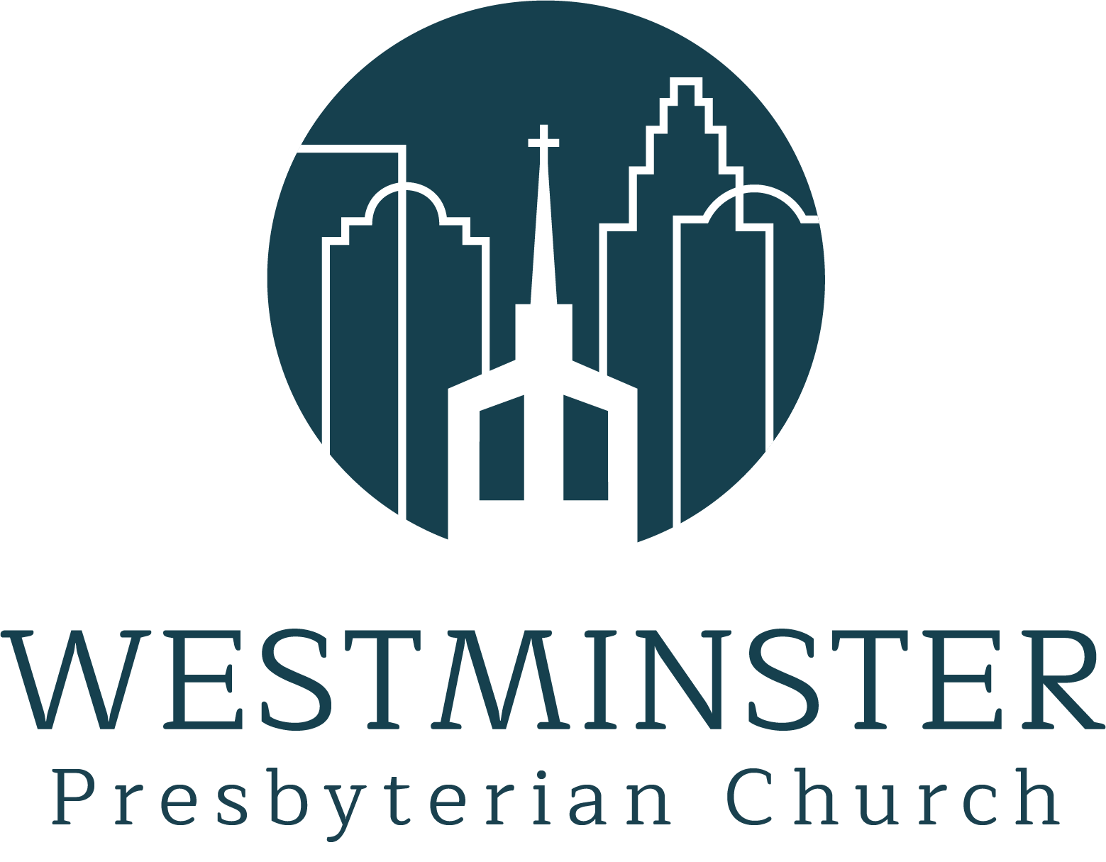

Inviting people to life in Christ…
lived together…
for the sake of others.

