Twelfth Sunday after Pentecost
August 31, 2025

PRELUDE Praise to the Lord, the Almighty
WELCOME TO WESTMINSTER Elder Dave Hiller
CHURCH FAMILY HIGHLIGHTS
PRAYER OF INVOCATION
† CALL TO WORSHIP from Psalm 107
Leader: Give thanks to the Lord, for he is good; his love endures forever.
People: Let the redeemed of the Lord tell their story— those he redeemed
from the hand of the foe, those he gathered from the lands, from
east and west, from north and south.
Leader: Let us give thanks to the Lord for his unfailing love and his wonderful
deeds for mankind,
People: For he satisfies the thirsty and fills the hungry with good things.
Leader: Let us sacrifice thank offerings and tell of His works with songs of joy.
People: Let us exalt him in the assembly of the people and praise Him in the
council of the elders.
† HYMNS OF PRAISE Come Thou Fount of Every Blessing (#2)
Build My Life
SCRIPTURE READING Psalm 112
PRAYER OF CONFESSION
Gracious God, you call us to draw near to you, but we keep our distance. You call us to throw off the things that keep us from you, but we hold them too tightly. You call us to run the race of faith with perseverance, but we give up so easily. Father, forgive our sins and help us trust in the promise of your goodness and your strength. Restore our relationships with you and one another that we might boldly follow you together. By your grace, make us a light by which others come to know, love and follow you as well. In Jesus’ name we pray...
(Prayers of silent confession)
ASSURANCE OF FORGIVENESS
† DOXOLOGY

rECEPTION OF COVENANT PARTNERS
Brenda Ward
JUNIOR CHURCH
† HYMN OF PREPARATION The Solid Rock (#404)
SCRIPTURE READING Hebrews 12:1-3
SERMON Running the Race Together
Rev. Owen Stepp
Pastoral Prayer & Lord’s Prayer
Our Father, who art in heaven, hallowed be thy name. Thy kingdom come; thy will be done on earth as it is in heaven. Give us this day our daily bread and forgive us our debts, as we forgive our debtors. Lead us not into temptation but deliver us from the evil one. For thine is the kingdom, and the power, and the glory, forever and ever. AMEN.
† HYMN OF RESPONSE All the Way My Savior Leads Me
† AFFIRMATION OF FAITH From The Barmen Declaration
As Jesus Christ is God’s assurance of the forgiveness of all our sins, so in the same way and with the same seriousness is he also God’s mighty claim upon our whole life. Through him befalls us a joyful deliverance from the godless fetters of this world for a free, grateful service to his creatures.
We reject the false doctrine, as though there were areas of our life in which we would not belong to Jesus Christ, but to other lords—areas in which we would not need justification and sanctification through him.
† BENEDICTION
POSTLUDE Oh, That I Had a Thousand Voices
Our Prayer Team will be available to pray with anyone in the Chapel following the service.

Welcome to Westminster Presbyterian Church
We are thankful you are here worshiping with us. We invite you to register your attendance with us today on the friendship pad found at the end of the pew.

Upcoming Events
September 7th – Our new worship service launches at 8:30 and includes weekly communion, interactive prayer and new opportunities to serve.

September 14th - Second Sunday Lunch – Join us for fellowship right after the 11am service and hear about the highlights from the Scotland Mission Team.

September 21st – Third Third Gathering – The vision is to engage, encourage and equip those entering the “third season” of life. (60+years).

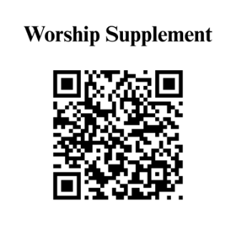

Find out more about Westminster by scanning the codes below with your phone’s camera:


101 Colville Road, Charlotte, NC 28207 | 704-376-0751 | westminstercharlotte.org

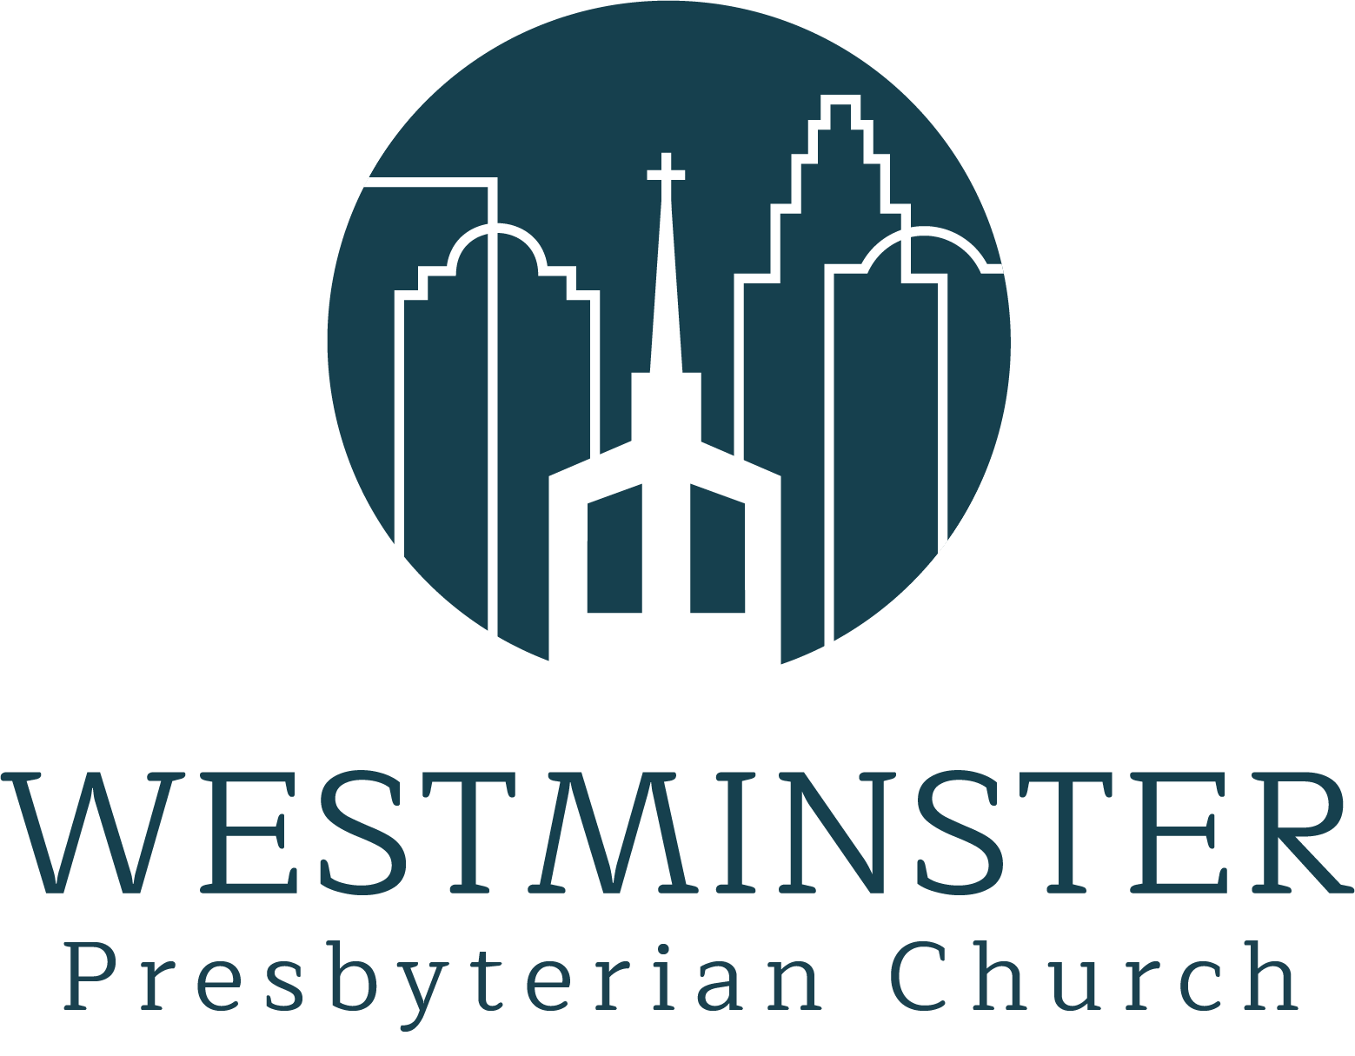

Inviting people to life in Christ
lived together
for the sake of others.

