Eighth Sunday after Pentecost

August 3, 2025

**PRELUDE**  *God Is My Strong Salvation*

**WELCOME TO WESTMINSTER** ElderCarol Sample

**PRAYER OF INVOCATION**

**† CALL TO WORSHIP**  *from Ezekiel 34*

Leader: Happy are those whose help is the God of Jacob, whose hope is in

the Lord their God.

**People: Who made heaven and earth, the sea, and all that is in them;**

**who keeps faith forever.**

Leader: The Lord sets the prisoners free, opens the eyes of the blind, and lifts

up those who are bowed down.

**People: The Lord will reign forever, your God, O Zion, for all**

**generations. Praise the Lord!**

**All: Let us worship the Lord our God!**

**† HYMNS OF PRAISE**  *Bless the Lord, O My Soul*

*Come, Thou Fount of Every Blessing (#2)*

**PRAYER OF CONFESSION**

God of our hearts, we come to You admitting that we are lost. In our lives of chaos, we have lost our peace. In our selfishness, we have lost our ability to care for others. In our self-reliance, we have lost our total dependence on You. We ask for Your forgiveness and mercy for our wandering hearts. Remind us that it is by Your grace we are found. In the Name of Jesus we pray...

*(Prayers of silent confession)*

**ASSURANCE OF FORGIVENESS**

**† Doxology**

**JUNIOR CHURCH**

**OFFERING**

**SCRIPTURE READING** Luke 15:1-7

**SERMON**  *Eating with Tax Collectors and Sinners*

Rev. Owen Stepp

**† AFFIRMATION OF FAITH** Psalm 23

The Lord is my shepherd, I lack nothing. He makes me lie down in green pastures, he leads me beside quiet waters, he refreshes my soul. He guides me along the right paths for his name’s sake. Even though I walk through the darkest valley, I will fear no evil, for you are with me; your rod and your staff, they comfort me. You prepare a table before me in the presence of my enemies. You anoint my head with oil; my cup overflows. Surely your goodness and love will follow me all the days of my life, and I will dwell in the house of the Lord forever.

**The Lord’s Supper**

**Invitation**

**Words of Institution**

**Prayer of Thanksgiving**

**Communion songs**  *There’s a Wideness in God’s Mercy*

*Grace Greater Than Our Sin (#201)*

*We invite all who have put their faith in Christ and been baptized to come to the Lord’s Table. We believe that children should be instructed on the meaning of the sacrament prior to receiving the Supper. Whether you are receiving communion or not we invite everyone to come forward and receive a blessing from the pastors during this time.*

**Pastoral Prayer & Lord’s Prayer**

Our Father, who art in heaven, hallowed be thy name. Thy kingdom come; thy will be done on earth as it is in heaven. Give us this day our daily bread and forgive us our debts, as we forgive our debtors. Lead us not into temptation but deliver us from the evil one. For thine is the kingdom, and the power, and the glory, forever and ever. AMEN.

**† HYMN OF RESPONSE** *Amazing Grace (#202)*

**† BENEDICTION**

**POSTLUDE** *Rejoice, the Lord Is King*

*Our Prayer Team will be available to pray with anyone in the Chapel following the service.*

Welcome to Westminster Presbyterian Church

*We are thankful you are here worshiping with us. We invite you to register your attendance with us today on the friendship pad found at the end of the pew.*

**Around the Table this Week**

When is a time that you were lost?

**Upcoming Events**

August 8th-10th – Youth Beach Trip

August 17th – Charlotte Knights Game – Join us for the annual Charlotte Knights

game! Get your tickets now!

August 24th – Rally Day to kick off the new Sunday School year.

September 14th – Second Sunday Lunch – Scotland Trip

*Find out more about Westminster by scanning the codes below with your phone’s camera:*

101 Colville Road, Charlotte, NC 28207 | 704-376-0751 | westminstercharlotte.org

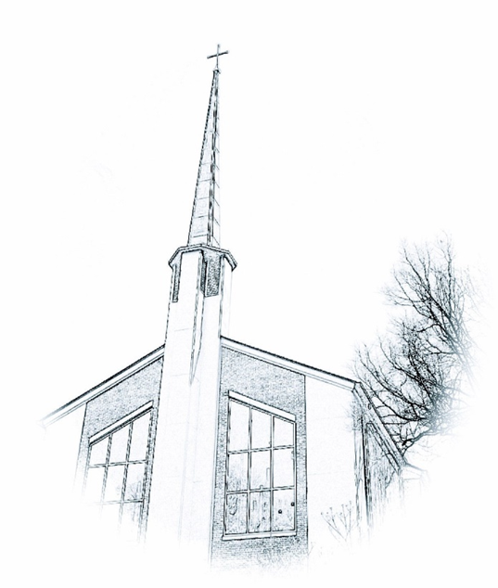

*Inviting people to life in Christ…*

*lived together…*

*for the sake of others.*