Twenty-Third Sunday after Pentecost
November 16 , 2025

PRELUDE How Firm a Foundation
WELCOME TO WESTMINSTER Elder Carol Sample
PRAYER OF INVOCATION
† CALL TO WORSHIP from Isaiah 12
Leader: Surely God is my salvation; I will trust and will not be afraid,
People: For the LORD is my strength and my might; he has become my
salvation.
Leader: With joy you will draw water from the wells of salvation.
People: And you will say on that day: Give thanks to the LORD; call on
his name; make known his deeds among the nations; proclaim
that his name is exalted.
Leader: Sing praises to the LORD, for he has done gloriously;
People: Let this be known in all the earth.
† HYMNS OF PRAISE How Firm a Foundation (#275)
Build My Life
SCRIPTURE READING Psalm 98
PRAYER OF CONFESSION
Gracious Father, we confess that we fail to be generous toward others even though you have been so generous with us. Every good gift in our lives comes from your hand. In our sin, we seek maximum return and minimum sacrifice for ourselves. Lord Jesus, we know that this is not your way. Holy Spirit, renew and shape our hearts in gratitude. Open our hands to give so that others might experience your generous abundance. Give us the grace to be rich in your mercy and in good deeds that reflect your glory. In Jesus’ name we pray...
(Prayers of silent confession)
ASSURANCE OF FORGIVENESS
† DOXOLOGY

JUNIOR CHURCH
OFFERING
† HYMN OF PREPARATION The Solid Rock (#404)
† SCRIPTURE READING 1 Timothy 6:17-21
SERMON How to be Rich
Rev. Owen Stepp
Pastoral Prayer & tHE Lord’s Prayer
Our Father, who art in heaven, hallowed be thy name. Thy kingdom come; thy will be done on earth as it is in heaven. Give us this day our daily bread and forgive us our debts, as we forgive our debtors. Lead us not into temptation but deliver us from the evil one. For thine is the kingdom, and the power, and the glory, forever and ever. AMEN.
† AFFIRMATION OF FAITH Apostles’ Creed

I believe in God the Father Almighty; Maker of heaven and earth.

And in Jesus Christ His only Son, our Lord; who was conceived by the Holy Ghost, born of the Virgin Mary, suffered under Pontius Pilate, was crucified, dead, and buried; he descended into hell; the third day he rose again from the dead; he ascended into heaven and sitteth on the right hand of God the Father Almighty; from thence he shall come to judge the quick and the dead.

I believe in the Holy Ghost, the holy catholic Church, the communion of saints, the forgiveness of sins, the resurrection of the body, and the life everlasting. AMEN.
† HYMN OF RESPONSE All the Way My Savior Leads Me
† BENEDICTION
POSTLUDE Allegro from Voluntary in C

Our Prayer Team will be available to pray with anyone in the Chapel following the service

Welcome to Westminster Presbyterian Church
We are thankful you are here worshiping with us. We invite you to register your attendance with us today on the friendship pad found at the end of the pew.

Upcoming Events

Nov 16th – 12:15pm - Second Sunday Lunch - Join us for fellowship following the 11am service.
Nov 16th – 12:15pm - Welcome to Westminster - Join us in Younts Parlor to learn more about Westminster and how you can get connected. Lunch will be provided.
Nov 16th - 5:30pm - Third Third Gathering - The vision is to engage, encourage and equip those entering the “third season” of life. (60+years).
Nov 23rd – 12:15pm – The Hanging of the Greens. Join us to help decorate the church for the Advent Season.
Nov 30th – 5:00pm - Sundays in Song – Carols, Cookies and Cocoa

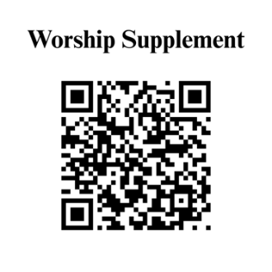

Find out more about Westminster by scanning the codes below with your phone’s camera:


101 Colville Road, Charlotte, NC 28207 | 704-376-0751 | westminstercharlotte.org

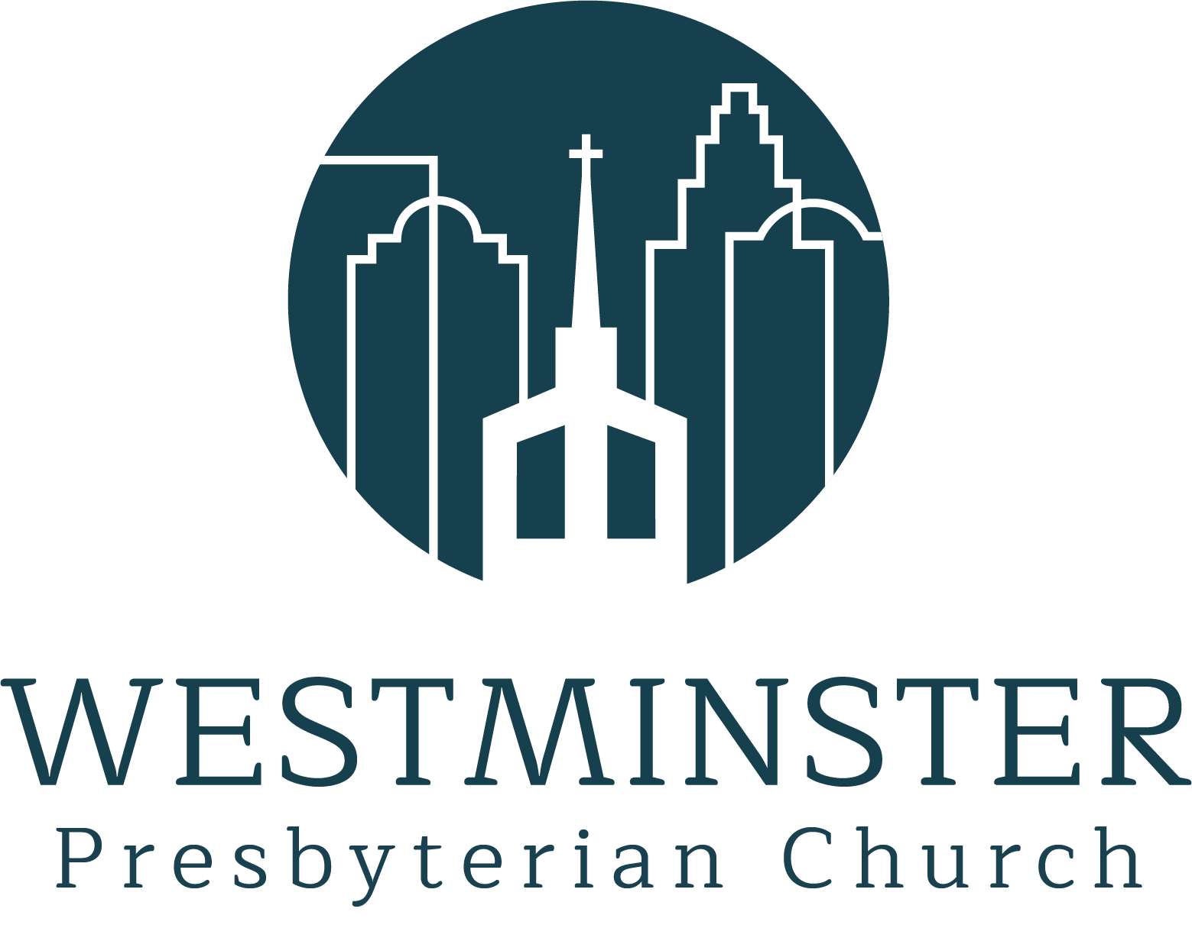

Inviting people to life in Christ…
lived together…
for the sake of others.

