Sixth Sunday after Pentecost

July 20, 2025

**PRELUDE**  *Simple Gifts*

**WELCOME TO WESTMINSTER** ElderDennis Chen

**PRAYER OF INVOCATION**

**† CALL TO WORSHIP**  *from Psalm 99*

Leader: The Lord reigns, let the nations tremble;  
**People: He sits enthroned between the cherubim, let the earth shake.**  
Leader: Great is the Lord in Zion; he is exalted over all the nations.  
**People: Let them praise your great and awesome name— he is holy.**

Leader: Exalt the Lord our God and worship at his footstool; he is holy.

**People:  Let us worship the Lord our God.**

**† HYMNS OF PRAISE** *Joyful, Joyful, We Adore Thee (#1)*

*Gratitude*

**PRAYER OF CONFESSION**

Father God, we confess that the actions of our hands often do not match the words of our mouths. We say one thing and do another. We give you praise and curse a friend, we sing songs of thanksgiving and gossip about another. Forgive us for those words and deeds that have grieved your heart. Where we harbor hypocrisy in our lives, please reveal it. Where we practice deception, please bring truth. In your goodness and mercy, forgive us for Jesus’ sake. Heal us so that we might be pure in heart and see you. In our Savior’s name we pray...

*(Prayers of silent confession)*

**ASSURANCE OF FORGIVENESS**

**† Doxology**

**JUNIOR CHURCH**

**OFFERING**

**Song of preparation**  *Humble Thyself in the Sight of the Lord*

**SCRIPTURE READING** Luke 11:37-54

**SERMON**  *To be Rather Than to Seem*

Rev. Owen Stepp

**† AFFIRMATION OF FAITH** Heidelberg Catechism

Q. #1 What is your only comfort in life and in death?

**A. That I am not my own, but belong body and soul, in life and in death to my faithful Savior, Jesus Christ. He has fully paid for all my sins with his precious blood, and has set me free from the tyranny of the devil. He also watches over me in such a way that not a hair can fall from my head without the will of my Father in heaven; in fact, all things must work together for my salvation. Because I belong to him, Christ, by his Holy Spirit, assures me of eternal life and makes me wholeheartedly willing and ready from now on to live for him.**

**Pastoral Prayer & Lord’s Prayer**

Our Father, who art in heaven, hallowed be thy name. Thy kingdom come; thy will be done on earth as it is in heaven. Give us this day our daily bread and forgive us our debts, as we forgive our debtors. Lead us not into temptation but deliver us from the evil one. For thine is the kingdom, and the power, and the glory, forever and ever. AMEN.

**† HYMN OF RESPONSE** *I Surrender All (#366)*

**† BENEDICTION**

**POSTLUDE**

*Our Prayer Team will be available to pray with anyone in the Chapel following the service.*

Welcome to Westminster Presbyterian Church

*We are thankful you are here worshiping with us. We invite you to register your attendance with us today on the friendship pad found at the end of the pew.*

**Around the Table this Week**

When is a time someone told you the truth about yourself that you did not want to hear but needed to hear?

**Upcoming Events**

**July 21st-24th** – Vacation Bible School – We are traveling to Egypt this year to experience Joseph's adventures and learn how God gives us hope, special abilities, wisdom, forgiveness, and family.

**July 27th –** Third Third Hymn Sing - The Third Third Family is hosting an All-Church Hymn Sing and Ice-Cream Social at 4pm in Beard Hall.

**August 8th-10th** – High School Beach Trip – We will grow deeper in our relationships with Christ as we enjoy fellowship with each other.

**August 17th –** Charlotte Knights Game – Join us for the annual Charlotte Knights game!

*Find out more about Westminster by scanning the codes below with your phone’s camera:*

*

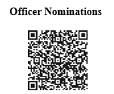

101 Colville Road, Charlotte, NC 28207 | 704-376-0751 | westminstercharlotte.org

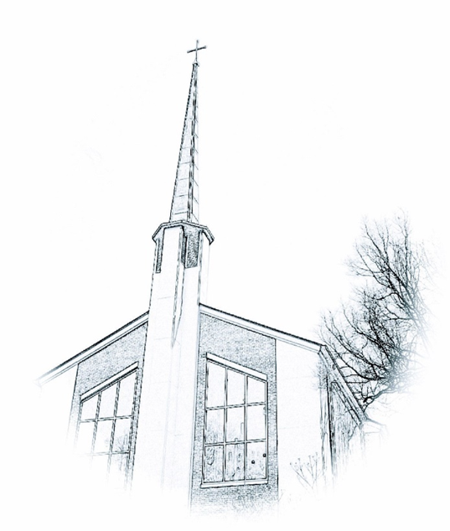

*Inviting people to life in Christ…*

*lived together…*

*for the sake of others.*