Third Sunday of Advent
December 14 , 2025

PRELUDE "Nun seid ihr wohl gerochen" from Christmas Oratorio
WELCOME TO WESTMINSTER Elder Dennis Hollinger
PRAYER OF INVOCATION
† CALL TO WORSHIP from Psalm 98
Leader: Oh, sing to the Lord a new song, for he has done marvelous
things!
People: All the ends of the earth have seen the salvation of our God.
Leader: He has remembered his love and his faithfulness to Israel; all the
ends of the earth have seen the salvation of our God.
People: Let the hills sing for joy together before the Lord, for he comes
to judge the earth.
Leader: Shout for joy to the Lord, all the earth!
People: Let us worship the Lord!
† HYMNS OF PRAISE Let All Mortal Flesh Keep Silence
Joy To The World (#125)
SCRIPTURE READING Isaiah 35:1-10
LIGHTING OF THE ADVENT CANDLE
Andrew, Emma, Isla, Ollie and Eliza Schoenbeck
PRAYER OF CONFESSION
Gracious God, you call us to be a joyful people, giving thanks for you and all of your good gifts. But there are times when sin and sorrow grow, and we are consumed by the thorns infesting the world around us. They choke out our joy. We lose sight of your grace and instead fall into despair. We are consumed by loss, distracted by stuff, and crippled with fear. We focus on our lack, rather than your abundance. Lift our eyes, Lord, and renew our joy in you. Grant us your joy that is abundant and eternal. Through Christ we pray...
(Prayers of silent confession)
ASSURANCE OF FORGIVENESS
† DOXOLOGY
JUNIOR CHURCH
RECEPTION OF NEW COVENANT PARTNERS
Tyler and Heather Durham Chris and Caroline Pappas
Thomas and Jodie Lawson Jamie Walters
OFFERING
† SCRIPTURE READING Luke 1:46-55
SERMON Overflowing Joy
Rev. Owen Stepp
Pastoral Prayer & tHE Lord’s Prayer
Our Father, who art in heaven, hallowed be thy name. Thy kingdom come; thy will be done on earth as it is in heaven. Give us this day our daily bread and forgive us our debts, as we forgive our debtors. Lead us not into temptation but deliver us from the evil one. For thine is the kingdom, and the power, and the glory, forever and ever. AMEN.
† AFFIRMATION OF FAITH Apostles’ Creed

I believe in God the Father Almighty; Maker of heaven and earth.

And in Jesus Christ His only Son, our Lord; who was conceived by the Holy Ghost, born of the Virgin Mary, suffered under Pontius Pilate, was crucified, dead, and buried; he descended into hell; the third day he rose again from the dead; he ascended into heaven and sitteth on the right hand of God the Father Almighty; from thence he shall come to judge the quick and the dead.

I believe in the Holy Ghost, the holy catholic Church, the communion of saints, the forgiveness of sins, the resurrection of the body, and the life everlasting. AMEN.
† HYMN OF RESPONSE Hark! The Herald Angels Sing (#133)
† BENEDICTION
† POSTLUDE Hallelujah from Messiah
Please remain standing for the postlude as we sing together from the hymnal, Hallelujah (#37)
Our Prayer Team will be available to pray with anyone in the Chapel following the service

Welcome to Westminster Presbyterian Church
We are thankful you are here worshiping with us. We invite you to register your attendance with us today on the friendship pad found at the end of the pew.

Upcoming Events
Dec 14th – 12:15pm – Second Sunday Lunch – Join us following the 11am service for fellowship and food. High School Peru Mission Trip Interest Meeting, gather at Garrison’s table during lunch.
Dec 14th – 5:00pm – Lessons and Carols - Invite friends, family and neighbors for a special evening of scripture and music. Stay for light refreshments and more music afterward. Bring a finger food or some cookies to share.
Dec 17th – 6:00pm - Soup, Story and Sacrament. Join us in Beard Hall for a hearty soup, a Christmas story and the Lord’s Supper.
Dec 18th – 7:00pm – Together in Grief – A worship service of healing.
Dec 24th – 5:00pm – Christmas Eve Pageant – A family pageant for everyone, young and old. Parts for every child – no rehearsal required!
Dec 24th - 8:00pm – Christmas Eve Candlelight Service – Welcome the Christ Child with candlelight, communion, and carols.

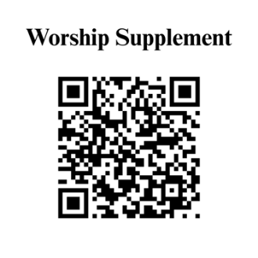

Find out more about Westminster by scanning the codes below with your phone’s camera:


101 Colville Road, Charlotte, NC 28207 | 704-376-0751 | westminstercharlotte.org

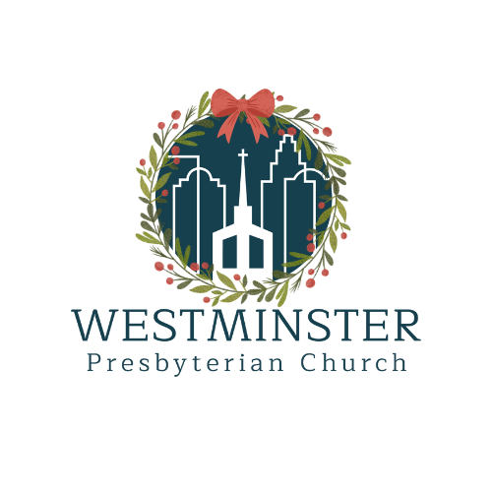

Inviting people to life in Christ…
lived together…
for the sake of others.

