Palm Sunday
March 29, 2026

PRELUDE All Glory, Laud and Honor
Palm Processional Praise the Lord
† Processional Hymn All Glory, Laud and Honor (#173)
WELCOME TO WESTMINSTER Elder Kelly Boyce
PRAYER OF INVOCATION
† CALL TO WORSHIP
Leader: Rejoice greatly, O people of Zion!
People: Shout in triumph, O people of Jerusalem!
Leader: See, your king is coming to you. He is righteous and having
salvation,
People: Yet he is humble, riding on a donkey—even on a donkey’s colt.
Leader: Blessed is He who comes in the name of the Lord.
People: Hosanna to the Son of David!
† HYMNS OF PRAISE Hosanna to the Son
Is He Worthy
SCRIPTURE READING Psalm 118:19-29
PRAYER OF CONFESSION
Lord God, you are our king, yet we do not act like it. You came in humility, to serve and give your life for the world. We do not follow your example. We live for ourselves and reject your example. We only claim allegiance to you when it’s convenient, when it serves our interests. Remembering the Palm Sunday crowd we are reminded of how quickly our loyalty to you fades and even disappears. Please forgive us for our self-centeredness, hypocrisy and apathy. Please give us passion for you our Lord as we remember your passion for us this week. In the name of Jesus we pray...
(Prayers of silent confession)
ASSURANCE OF FORGIVENESS

† DOXOLOGY
JUNIOR CHURCH
OFFERING
† CHORAL ANTHEM Ain't No Rock Gonna Shout for Me
† SCRIPTURE READING John 12:12-26
SERMON Looking Back
Rev. Owen Stepp
Pastoral Prayer & tHE Lord’s Prayer
Our Father, who art in heaven, hallowed be thy name. Thy kingdom come; thy will be done on earth as it is in heaven. Give us this day our daily bread and forgive us our debts, as we forgive our debtors. Lead us not into temptation but deliver us from the evil one. For thine is the kingdom, and the power, and the glory, forever and ever. AMEN.
† AFFIRMATION OF FAITH Apostles’ Creed

I believe in God the Father Almighty; Maker of heaven and earth.

And in Jesus Christ His only Son, our Lord; who was conceived by the Holy Ghost, born of the Virgin Mary, suffered under Pontius Pilate, was crucified, dead, and buried; he descended into hell; the third day he rose again from the dead; he ascended into heaven and sitteth on the right hand of God the Father Almighty; from thence he shall come to judge the quick and the dead.

I believe in the Holy Ghost, the holy catholic Church, the communion of saints, the forgiveness of sins, the resurrection of the body, and the life everlasting. AMEN.
† HYMN OF RESPONSE What Wondrous Love Is This (#177)
† BENEDICTION
POSTLUDE Voluntary
Our Prayer Team will be available to pray with anyone in the Chapel following the service.

Welcome to Westminster Presbyterian Church
We are thankful you are here worshiping with us. We invite you to register your attendance with us today on the friendship pad found at the end of the pew.

Upcoming Events
Tonight - 5:00pm - Sundays In Song - Come Away from Rush and Hurry - As part of our Lenten Session together, we will gather on Palm Sunday for a simple and reflective time of singing and scripture to prepare our hearts and mind for the journey of holy week.
April 2nd - 7:00pm - Maundy Thursday service. We join Jesus and the disciples around the table for the Last Supper and his arrest.
April 3rd - 12:00pm - Good Friday service. We watch with each other at the foot of the cross and hear Jesus' last words of love.
April 5th - 8:30 & 11:00am Easter Services. You are invited to bring flowers to decorate the cross.
April 26th – 7:00pm -Caroline Cobb concert in Beard Hall. Mark your calendars for a special evening as we welcome musical artist and storyteller Caroline Cobb.

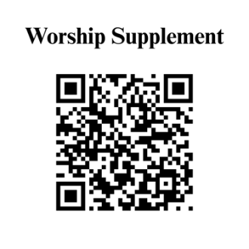

Find out more about Westminster by scanning the codes below with your phone’s camera:


101 Colville Road, Charlotte, NC 28207 | 704-376-0751 | westminstercharlotte.org

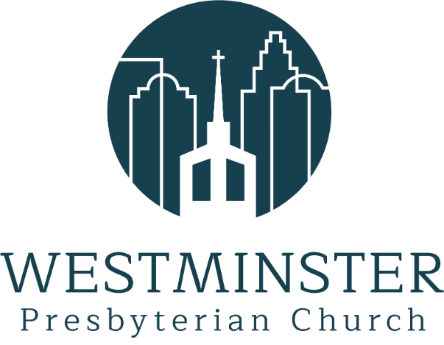

Inviting people to life in Christ…
lived together…
for the sake of others.

