Trinity Sunday

June 15, 2025

**PRELUDE**  *O Jesus, I Have Promised*

**WELCOME TO WESTMINSTER & PRAYER OF INVOCATION**

**† CALL TO WORSHIP**  from Psalm 8

Leader: O Lord, our Lord, how majestic is your name in all the earth!

**People: You have set your glory above the heavens.**

Leader: When I look at your heavens, the work of your fingers, the moon and

the stars, which you have set in place,

**People: What is man that you are mindful of him, and the son of man that**

**you care for him?**

Leader: Yet, you have made him a little lower than the heavenly beings and

crowned him with glory and honor.

**People:** **O Lord, our Lord, how majestic is your name in all the earth!**

**All: Let us praise the Father, praise the Son, and praise the Spirit**

**three in one!**

**† HYMNS OF PRAISE**  *All Creatures of Our God and King (#64)*

*King of Kings*

**SCRIPTURE READING** Genesis 1:26-31

**PRAYER OF CONFESSION**

Holy and gracious God, in your infinite love you have made us for Yourself. We come to you this morning desiring to know more of You so that we might love You more. Yet we confess our disordered hearts and minds fall short of Your majesty and Your mystery. We substitute counterfeit gods of this world to fill the ache that is in our hearts. We seek after earthly significance, purpose, and pleasure rather than resting in Your beauty and truth. We thirst for self-gratification and self-indulgence more than we thirst for Your heart of sacrificial love. Almighty God, forgive us all our sins through our Lord Jesus Christ and by the power of the Holy Spirit, keep us in Your Life that is both abundant and eternal. Hear us now in the quiet of our hearts as we confess our sins before Your healing throne of grace....

*(Prayers of silent confession)*

**ASSURANCE OF FORGIVENESS**

**† Doxology**

**JUNIOR CHURCH**

**CHURCH FAMILY HIGHLIGHTS**

**OFFERING**

**PRAYERS OF THE PEOPLE & THE LORD’S PRAYER**

Our Father, who art in heaven, hallowed be thy name. Thy kingdom come; thy will be done on earth as it is in heaven. Give us this day our daily bread and forgive us our debts, as we forgive our debtors. Lead us not into temptation but deliver us from the evil one. For thine is the kingdom, and the power, and the glory, forever and ever. *Amen*.

**anthem** *I Will Not Leave You Comfortless*

**SCRIPTURE READING** John 17:20-26

**SERMON**  *The Life of the Trinity*

Rev. Dr. Leslie S. Dibble

**† AFFIRMATION OF FAITH** Nicene Creed

We believe in one God, the Father, the Almighty, maker of heaven and earth, of all that is, seen and unseen.

We believe in one Lord, Jesus Christ, the only Son of God, eternally begotten of the Father, God from God, Light from Light, true God from true God, begotten, not made, of one being with the Father.  Through him all things were made.  For us and for our salvation he came down from heaven: by the power of the Holy Spirit he became incarnate from the Virgin Mary, and was made man.  For our sake he was crucified under Pontius Pilate; he suffered death and was buried.  On the third day he rose again in accordance with the Scriptures; he ascended into heaven and is seated at the right hand of the Father.  He will come again in glory to judge the living and the dead, and his kingdom will have no end.

We believe in the Holy Spirit, the Lord, the giver of life, who proceeds from the Father and the Son.  With the Father and the Son he is worshiped and glorified.  He has spoken through the Prophets.

We believe in one holy catholic and apostolic Church.  We acknowledge one baptism for the forgiveness of sins.  We look for the resurrection of the dead, and the life of the world to come. *Amen*.

**† HYMN OF RESPONSE** *How Great Is Our God*

**† BENEDICTION**

**POSTLUDE** *Fugue in C*

*Our Prayer Team will be available to pray with anyone in the Chapel following the service.*

Welcome to Westminster Presbyterian Church

*We are thankful you are here worshiping with us. We invite you to register your attendance with us today on the friendship pad found at the end of the pew.*

*Find out more about Westminster by scanning the codes below with your phone’s camera:*

101 Colville Road, Charlotte, NC 28207 | 704-376-0751 | westminstercharlotte.org

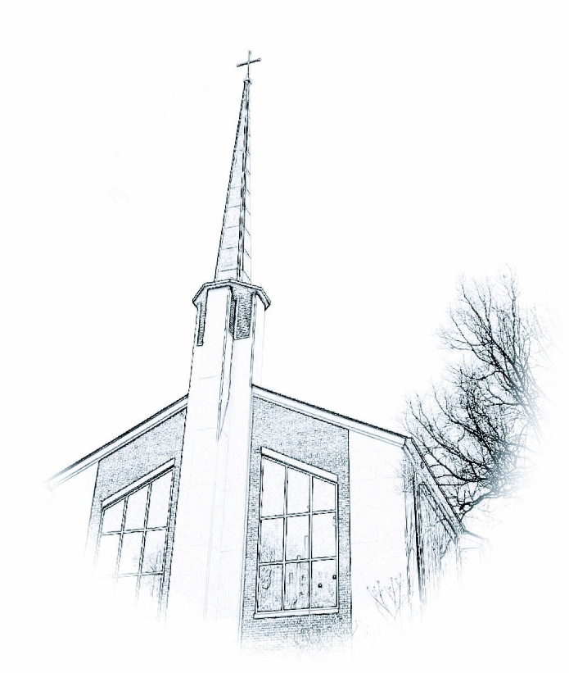

*Inviting people to life in Christ…*

*lived together…*

*for the sake of others.*