Ninth Sunday after Pentecost

August 10, 2025

**PRELUDE**  *Largo from Xerxes*

**WELCOME TO WESTMINSTER** ElderBetty Smith

**PRAYER OF INVOCATION**

**† CALL TO WORSHIP**  *from Psalm 80*

Leader: Give ear, O Shepherd of Israel. You who are enthroned upon the

cherubim, shine forth.

**People: Stir up your might and come to save us!**

Leader: Give us life as we will call upon your name.

**People: Restore us O God; let your face shine that we might be saved.**

Leader: Let us worship the God who saves and restores us.

**People: Let us love the Lord with all of our heart, mind, soul and**

**strength.**

**† HYMNS OF PRAISE**  *Come, Thou Almighty King (#267)*

*Christ Be Magnified*

**PRAYER OF CONFESSION** *from Psalm 51*

Have mercy on me, O God, according to your unfailing love; according to your great compassion blot out my transgressions. Wash away all my iniquity and cleanse me from my sin. For I know my transgressions, and my sin is always before me. Against you, you only, have I sinned and done what is evil in your sight; so, you are right in your verdict and justified when you judge. Surely, I was sinful at birth, sinful from the time my mother conceived me. Yet you desired faithfulness even in the womb; you taught me wisdom in that secret place. Cleanse me with hyssop, and I will be clean; wash me, and I will be whiter than snow. Let me hear joy and gladness; let the bones you have crushed rejoice. Create in me a pure heart, O God, and renew a steadfast spirit within me.

*(Prayers of silent confession)*

**ASSURANCE OF FORGIVENESS**

**† DOXOLOGY**  *Glory to God, Whose Goodness Shines on Me*

**JUNIOR CHURCH**

**OFFERING**

**SCRIPTURE READING** Luke 19:1-10

**SERMON** *Breaking Bread with Zacchaeus*

Rev. Owen Stepp

**† HYMN OF RESPONSE** *Jesus I Come*

**Pastoral Prayer & Lord’s Prayer**

Our Father, who art in heaven, hallowed be thy name. Thy kingdom come; thy will be done on earth as it is in heaven. Give us this day our daily bread and forgive us our debts, as we forgive our debtors. Lead us not into temptation but deliver us from the evil one. For thine is the kingdom, and the power, and the glory, forever and ever. AMEN.

**† AFFIRMATION OF FAITH** Apostles’ Creed

I believe in God the Father Almighty; Maker of heaven and earth.

And in Jesus Christ His only Son, our Lord; who was conceived by the Holy Ghost, born of the Virgin Mary, suffered under Pontius Pilate, was crucified, dead, and buried; he descended into hell; the third day he rose again from the dead; he ascended into heaven and sitteth on the right hand of God the Father Almighty; from thence he shall come to judge the quick and the dead.

I believe in the Holy Ghost, the holy catholic Church, the communion of saints, the forgiveness of sins, the resurrection of the body, and the life everlasting. AMEN.

**† BENEDICTION**

**POSTLUDE** *Variations on “Guide Me, O Thou Great Jehovah”*

*Our Prayer Team will be available to pray with anyone in the Chapel following the service.*

Welcome to Westminster Presbyterian Church

*We are thankful you are here worshiping with us. We invite you to register your attendance with us today on the friendship pad found at the end of the pew.*

**Around the Table this Week**

What meal would you prepare if Jesus were coming to your house?

**Upcoming Events**

August 17th – Charlotte Knights Game – Join us for the annual Charlotte Knights

game! Get Your tickets now!

August 24th – Rally Day – Kick off for new Sunday School year.

September 7th – 8:30 Second Worship Service starts

*Find out more about Westminster by scanning the codes below with your phone’s camera:*

101 Colville Road, Charlotte, NC 28207 | 704-376-0751 | westminstercharlotte.org

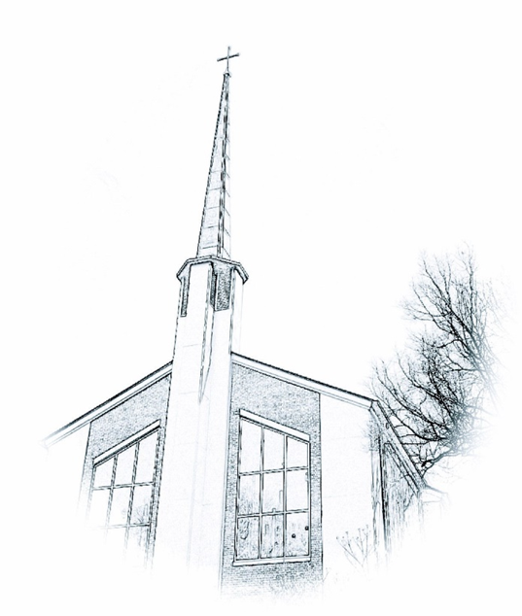

*Inviting people to life in Christ…*

*lived together…*

*for the sake of others.*