Seventh Sunday of Easter

June 1, 2025

**PRELUDE**  *Prelude on Brother James’s Air*

**WELCOME TO WESTMINSTER & PRAYER OF INVOCATION**

**† CALL TO WORSHIP**

Leader: I will sing of the Lord’s great love forever;  
**People: I will make His faithfulness known through all generations.**  
Leader: Dear friends, we should love each other, because love comes from

God.   
**People: Everyone who loves has become a child of God and knows God.**   
Leader: Whoever does not love does not know God, because God is love.   
**People: We love because God first loved us.**

**All: Let us love God with all of our heart, soul, mind and strength!**

**† HYMN OF PRAISE**  *Praise, My Soul, the King of Heaven (#3)*

**SCRIPTURE READING** Revelation 22:12-21

**PRAYER OF CONFESSION**

Heavenly father, your faithfulness and love endure forever, yet our gratitude fades on a daily basis. For your blessings that we see and fail to acknowledge, please forgive us. For your blessings that we fail to see and fail to acknowledge, please also forgive us. For failing to share your love and faithfulness with others, please forgive us. Lord of all goodness, please open our eyes to all that you are and all that do as we silently confess our sins to you now in the name of your Son our Savior Jesus…

*(Prayers of silent confession)*

**ASSURANCE OF FORGIVENESS**

**† Doxology**

**Sacrament of Baptism**

Frances Grace Ralston

Daughter of Thomas and Betsy Ralston

**† Hymn** *I Am For You*

**JUNIOR CHURCH**

**CHURCH FAMILY HIGHLIGHTS**

**OFFERING**

**PRAYERS OF THE PEOPLE & THE LORD’S PRAYER**

Our Father, who art in heaven, hallowed be thy name. Thy kingdom come; thy will be done on earth as it is in heaven. Give us this day our daily bread and forgive us our debts, as we forgive our debtors. Lead us not into temptation but deliver us from the evil one. For thine is the kingdom, and the power, and the glory, forever and ever. AMEN.

**SCRIPTURE READING** 1 John 4:7-21

**SERMON**  *The Fellowship of Love*

Rev. Owen Stepp

**† AFFIRMATION OF FAITH** John 15:12-17

**Jesus said**, “My command is this: Love each other as I have loved you. Greater love has no one than this: to lay down one’s life for one’s friends. You are my friends if you do what I command. I no longer call you servants, because a servant does not know his master’s business. Instead, I have called you friends, for everything that I learned from my Father I have made known to you. You did not choose me, but I chose you and appointed you so that you might go and bear fruit—fruit that will last—and so that whatever you ask in my name the Father will give you. This is my command: Love each other.”

**The Lord’s Supper**

**Invitation**

**Words of Institution**

**Prayer of Thanksgiving**

*We invite all who have put their faith in Christ and been baptized to come to the Lord’s Table. We believe that children should be instructed on the meaning of the sacrament prior to receiving the Supper. Whether you are receiving communion or not we invite everyone to come forward and receive a blessing from the pastors during this time.*

**Communion songs**  *The King of Love My Shepherd Is (#468)*

*Oh, the Deep, Deep Love of Jesus*

**† BENEDICTION**

**POSTLUDE** *Prelude in Classic Style*

*Our Prayer Team will be available to pray with anyone in the Chapel following the service.*

Welcome to Westminster Presbyterian Church

*We are thankful you are here worshiping with us. We invite you to register your attendance with us today on the friendship pad found at the end of the pew.*

*Find out more about Westminster by scanning the codes below with your phone’s camera:*

101 Colville Road, Charlotte, NC 28207 | 704-376-0751 | westminstercharlotte.org

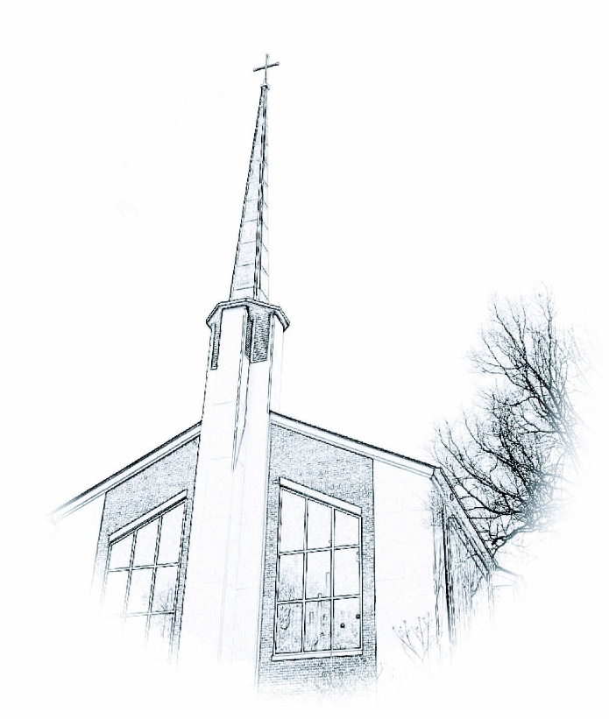

*Inviting people to life in Christ…*

*lived together…*

*for the sake of others.*