Fifth Sunday after Pentecost

July 13, 2025

**PRELUDE**  *My Jesus, I Love Thee*

**WELCOME TO WESTMINSTER** ElderLeigh Moran

**PRAYER OF INVOCATION**

**† CALL TO WORSHIP**

Leader: Come, all who are weary and worried, distracted and distant.

**People: We come to encounter the living Christ.**

Leader**:** Come, not just to do for Jesus, but to be with Him— to sit at His feet, to

listen, to be seen.

**People**: **We come to offer our attention and welcome His presence.**

Leader:In a world of hurry and hustle, Jesus invites us into His unhurried love.

**People: Let us worship with stillness, with openness, and with holy attentiveness.**

**† HYMNS OF PRAISE**  *What A Beautiful Name*

*My Jesus, I Love Thee (#364)*

**PRAYER OF CONFESSION**

Holy God, You are the One who is present with us, even when we are preoccupied and distracted. You invite us into a deep and abiding attentiveness—to You, to others, and even to our own souls. Yet so often we are anxious and burdened by many things. We define our worth by what we do, how we perform, and whether others approve. We confess that we often miss Your presence, because we are busy hosting expectations rather than receiving grace. Forgive us for the ways we welcome tasks over truth, control over connection. Renew in us the capacity to truly see You—to attend to what matters most, to make room for You and for others at the table. In Jesus’ name we pray…

*(prayers of silent confession)*

**ASSURANCE OF FORGIVENESS**

**† Doxology**

**JUNIOR CHURCH**

**OFFERING**

**SCRIPTURE READING** Luke 10:38-42

**SERMON**  *Meal at Mary and Martha’s Home*

Tamara Park Walters

**† AFFIRMATION OF FAITH** Nicene Creed

We believe in one God, the Father, the Almighty, maker of heaven and earth, of all that is, seen and unseen.

We believe in one Lord, Jesus Christ, the only Son of God, eternally begotten of the Father, God from God, Light from Light, true God from true God, begotten, not made, of one being with the Father.  Through him all things were made.  For us and for our salvation he came down from heaven: by the power of the Holy Spirit he became incarnate from the Virgin Mary, and was made man.  For our sake he was crucified under Pontius Pilate; he suffered death and was buried.  On the third day he rose again in accordance with the Scriptures; he ascended into heaven and is seated at the right hand of the Father.  He will come again in glory to judge the living and the dead, and his kingdom will have no end.

We believe in the Holy Spirit, the Lord, the giver of life, who proceeds from the Father and the Son.  With the Father and the Son he is worshiped and glorified.  He has spoken through the Prophets.

We believe in one holy catholic and apostolic Church.  We acknowledge one baptism for the forgiveness of sins.  We look for the resurrection of the dead, and the life of the world to come. Amen.

**Pastoral Prayer & Lord’s Prayer**

Our Father, who art in heaven, hallowed be thy name. Thy kingdom come; thy will be done on earth as it is in heaven. Give us this day our daily bread and forgive us our debts, as we forgive our debtors. Lead us not into temptation but deliver us from the evil one. For thine is the kingdom, and the power, and the glory, forever and ever. AMEN.

**† HYMNS OF RESPONSE** *Turn Your Eyes*

*Fairest Lord Jesus (#88)*

**† BENEDICTION**

**POSTLUDE**

*Our Prayer Team will be available to pray with anyone in the Chapel following the service.*

Welcome to Westminster Presbyterian Church

*We are thankful you are here worshiping with us. We invite you to register your attendance with us today on the friendship pad found at the end of the pew.*

**Around the Table Question**

In your life right now, where do you sense God inviting you to deeper attentiveness—  
to Him, to someone around you, or to your own soul? (And what tends to distract or keep you from being present in that space?)

**Upcoming Events**

July 21st-24th – Vacation Bible School – We are traveling to Egypt this year to experience Joseph's adventures and learn how God gives us hope, special abilities, wisdom, forgiveness, and family.

July 27th – Hymn Sing- The Third Third Family is hosting an All-Church Hymn Sing and Ice-Cream Social on Sunday July 27th at 4pm in Beard Hall. All are welcome.

August 17th – Charlotte Knights Game – Join us for the annual Charlotte Knights game!

*Find out more about Westminster by scanning the codes below with your phone’s camera:*

**Officer Nominations QR Code**



101 Colville Road, Charlotte, NC 28207 | 704-376-0751 | westminstercharlotte.org

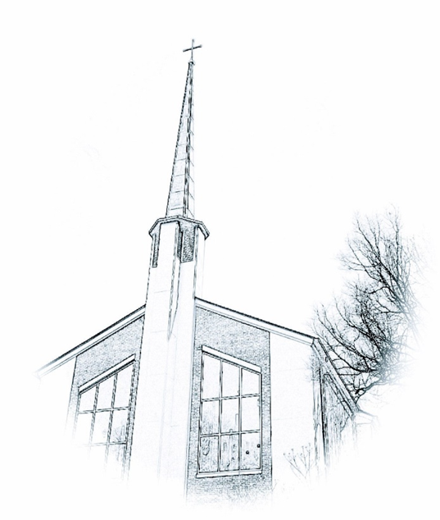

*Inviting people to life in Christ…*

*lived together…*

*for the sake of others.*