Easter Sunday

April 20, 2025

**PRELUDE**  *Christus Resurrexit*

**WELCOME TO WESTMINSTER & PRAYER OF INVOCATION**

**introit** *Forth He Came At Easter (8:30)*

*The Lord Is Risen (He Is Risen Indeed) (11:00)*

**† CALL TO WORSHIP**

Leader: Christ is risen!

**People: Christ is risen indeed.**

Leader: Light out of darkness!

**People: Life out of death!**

Leader: Hope out of despair!

**People: Power out of surrender!**

Leader: God, this is your grace, marvelous and wonderful!

**People: This is your way, always and forever.**

Leader: You raise us up with Christ, and we thank you.  
 **People:** **If we have been united with him in a death like his, we will**

**certainly also be united with him in a resurrection like his.**

**Alleluia!**

**† HYMNS OF PRAISE**  *King of Kings*

*Christ The Lord is Risen Today(#217)*

**SCRIPTURE READING** John 20:1-18

**PRAYER OF CONFESSION**

Merciful Father, even in our Easter joy, we confess before you our failings and sin. We confess that we are nothing apart from you and the resurrection life that you give in Jesus. In our thoughts, words, and actions, we act as if we have not known this resurrection. Forgive us for our many sins against you and against one another. Cleanse and renew us by your grace that we may rise to newness of life with our risen Lord and Savior. We believe that Jesus Christ who died for us is risen! We trust that in His sacrificial death and triumphant resurrection, Jesus Christ has won the victory over sin, death, and the devil. We know that through Him, our sins are forgiven. Restore us to the new life and salvation that you give! In name of our risen savior we pray...

*(Prayers of silent confession)*

**ASSURANCE OF FORGIVENESS**

**† Hymn of forgiveness** *Now Is Christ Risen From The Dead*

**JUNIOR CHURCH** *(11:00 only)*

**CHURCH FAMILY HIGHLIGHTS**

**OFFERING**

**PRAYERS OF THE PEOPLE & THE LORD’S PRAYER**

Our Father, who art in heaven, hallowed be thy name. Thy kingdom come; thy will be done on earth as it is in heaven. Give us this day our daily bread and forgive us our debts, as we forgive our debtors. Lead us not into temptation but deliver us from the evil one. For thine is the kingdom, and the power, and the glory, forever and ever. AMEN.

**anthem**  *The Strife Is O’er (11:00)*

**SCRIPTURE READING** John 11:17-27

Leader: This is the Word of the Lord.

**People: Thanks be to God!**

**SERMON** *Portraits of Jesus: I Am The Resurrection and The Life*

Rev. Owen Stepp

**† AFFIRMATION OF FAITH** Apostles’ Creed

I believe in God the Father Almighty; Maker of heaven and earth.

And in Jesus Christ His only Son, our Lord; who was conceived by the Holy Ghost, born of the Virgin Mary, suffered under Pontius Pilate, was crucified, dead, and buried; he descended into hell; the third day he rose again from the dead; he ascended into heaven and sitteth on the right hand of God the Father Almighty; from thence he shall come to judge the quick and the dead.

I believe in the Holy Ghost, the holy catholic Church, the communion of

saints, the forgiveness of sins, the resurrection of the body, and the life

everlasting. AMEN.

**† HYMNS OF RESPONSE** *Thine Is The Glory*

*Christus Victor (Amen)* *(11:00)*

**† BENEDICTION**

**POSTLUDE** *Easter Postlude on “Handel”*

*Our Prayer Team will be available to pray with anyone in the Chapel following the service.*

Welcome to Westminster Presbyterian Church

*We are thankful you are here worshiping with us. We invite you to register your attendance with us today on the friendship pad found at the end of the pew.*

**Upcoming Events**

*Sign up here for all upcoming events.*

**

**WPC Newsletter**

*Please use the QR code to see our Newsletter.*



**Worship Supplement**

*.*

101 Colville Road, Charlotte, NC 28207 | 704-376-0751 | westminstercharlotte.org

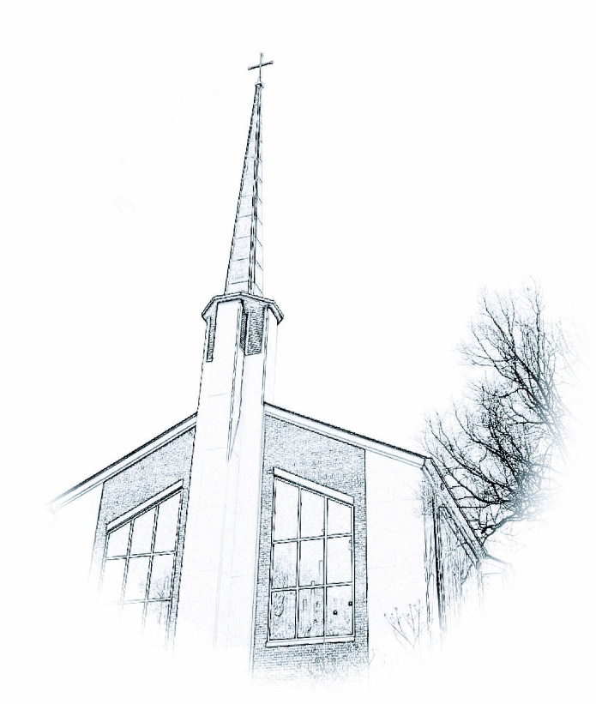

*Inviting people to life in Christ…*

*lived together…*

*for the sake of others.*