Twenty First Sunday after Pentecost
November 2 , 2025

PRELUDE “Nimrod” from Enigma Variations
WELCOME TO WESTMINSTER Elder Betty Smith
PRAYER OF INVOCATION
† CALL TO WORSHIP from Psalm 22
Leader: All the ends of the earth will remember and turn to the Lord,
People: And all the families of the nations will bow down before him,
Leader: For dominion belongs to the Lord and he rules over the nations.
People: All the rich of the earth will feast and worship; all who go down
to the dust will kneel before him— those who cannot keep
themselves alive.
Leader: Posterity will serve him; future generations will be told about the
Lord.
People: They will proclaim his righteousness, declaring to a people yet
unborn: He has done it!
Leader: Let us worship God!
† HYMNS OF PRAISE O God Our Help In Ages Past (#52)
Christ Be Magnified
SCRIPTURE READING Joshua 1:1-9
PRAYER OF CONFESSION
Father, we confess that we boast about our success and security. By our words and deeds, we have denied you more than we have desired you. We have cowered when we needed to be courageous. Jesus, we long to be people who follow you no matter the cost. But the distractions and desires of this world cause us to wander away. Holy Spirit, sanctify us. Cleanse us from sin. Give us the desire, faith, and strength to live the life to which you have called us.
(Prayers of silent confession)
ASSURANCE OF FORGIVENESS
† DOXOLOGY
REMEBRANCES OF SAINTS DEPARTED
CHORAL ANTHEM I Know That My Redeemer Lives
JUNIOR CHURCH
OFFERING
Pastoral Prayer & tHE Lord’s Prayer
Our Father, who art in heaven, hallowed be thy name. Thy kingdom come; thy will be done on earth as it is in heaven. Give us this day our daily bread and forgive us our debts, as we forgive our debtors. Lead us not into temptation but deliver us from the evil one. For thine is the kingdom, and the power, and the glory, forever and ever. AMEN.
SCRIPTURE READING 1 Corinthians 16:13-24
SERMON Stand Firm
Rev. Owen Stepp
† AFFIRMATION OF FAITH Apostle’s Creed

I believe in God the Father Almighty; Maker of heaven and earth.

And in Jesus Christ His only Son, our Lord; who was conceived by the Holy Ghost, born of the Virgin Mary, suffered under Pontius Pilate, was crucified, dead, and buried; he descended into hell; the third day he rose again from the dead; he ascended into heaven and sitteth on the right hand of God the Father Almighty; from thence he shall come to judge the quick and the dead.

I believe in the Holy Ghost, the holy catholic Church, the communion of saints, the forgiveness of sins, the resurrection of the body, and the life everlasting. AMEN.
The Lord’s Supper

Invitation
Words of Institution

Prayer of Thanksgiving

Communion songs On Jordan’s Stormy Banks

We Will Feast in the House of Zion

We invite all who have put their faith in Christ and been baptized to come to the Lord’s Table. We believe that children should be instructed on the meaning of the sacrament prior to receiving the Supper. Whether you are receiving communion or not we invite everyone to come forward and receive a blessing from the pastors during this time.
† HYMN OF RESPONSE For All The Saints (#546)
† BENEDICTION
POSTLUDE For All the Saints
Our Prayer Team will be available to pray with anyone in the Chapel following the service

Welcome to Westminster Presbyterian Church
We are thankful you are here worshiping with us. We invite you to register your attendance with us today on the friendship pad found at the end of the pew.
Upcoming Events
Sept 24th – Nov 5th – 5:30pm - Westminster Wednesday Dinner and program featuring a video series “Practicing the Way” with John Mark Comer.
Nov. 2nd – 5:00pm - Youth Group – Will be held in Youth Room.
Nov 16th – 12:15pm - Second Sunday Lunch - Join us for fellowship right after the 11am service.
Nov 16th – 12:15pm - Welcome to Westminster - Join us to learn more about Westminster and how you can get connected.
Nov 16th - 5:30pm - Third Third Gathering - The vision is to engage, encourage and equip those entering the “third season” of life. (60+years).

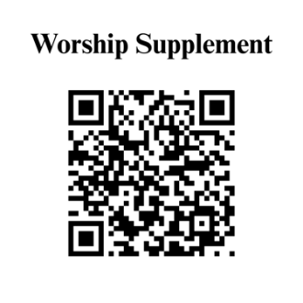

Find out more about Westminster by scanning the codes below with your phone’s camera:


101 Colville Road, Charlotte, NC 28207 | 704-376-0751 | westminstercharlotte.org

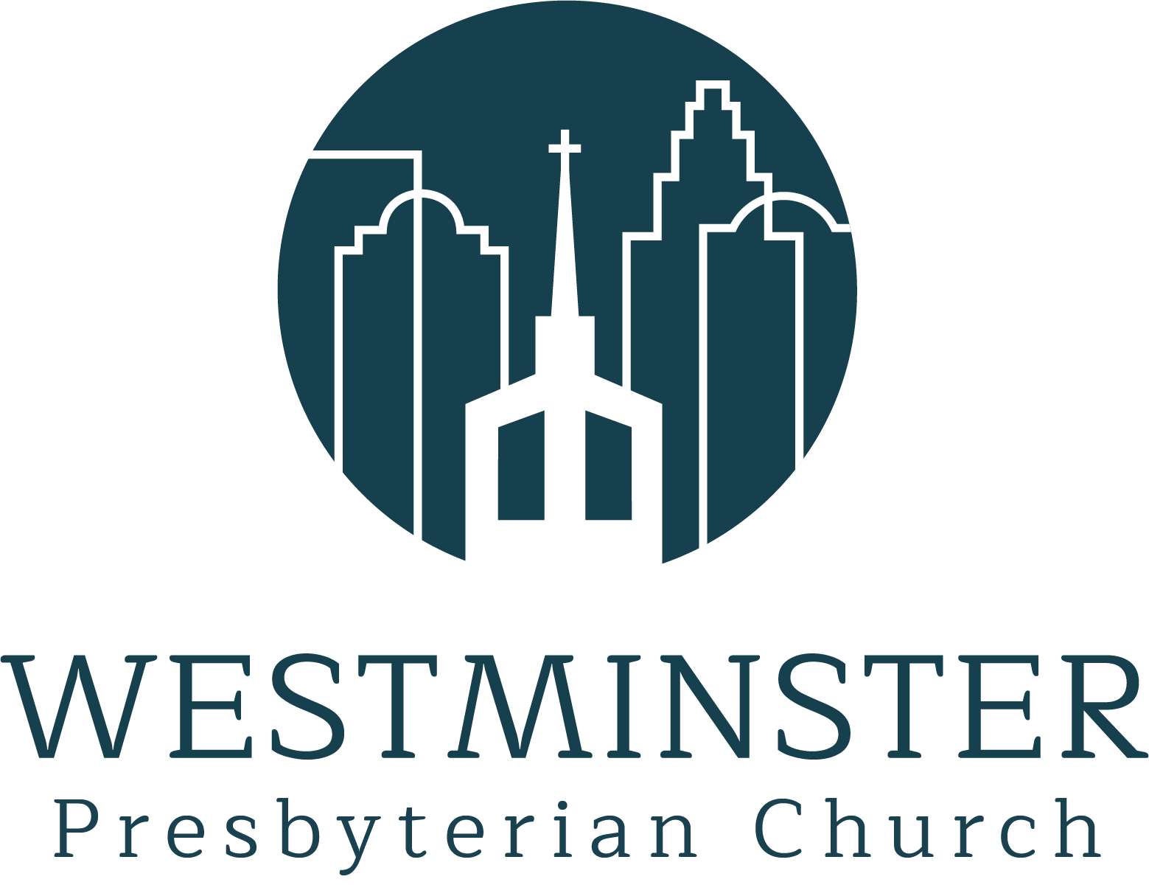

Inviting people to life in Christ…
lived together…
for the sake of others.

