Fourth Sunday of Lent

March 30, 2025

**PRELUDE**  *Chorale Prelude on RATHBUN*

**WELCOME TO WESTMINSTER & PRAYER OF INVOCATION**

**† CALL TO WORSHIP**  adapted from Psalm 23

Leader: Lord, You are our shepherd, we shall not want.

**People: You make us lie down in green pastures; You lead us beside still**

**waters; You restore our soul. You lead us in right paths for Your**

**name's sake.**

Leader: Even though we walk through the valley of the shadow of death, we

will fear no evil; for You are with us; Your rod and Your staff, they

comfort us.

**People: You prepare a table before us in the presence of our enemies;**

**You anoint our heads with oil; our cups overflow.**

Leader: Surely goodness and mercy shall follow us all the days of our lives,

and we shall dwell in the house of the Lord forever.

**People: Let us worship the Lord who is our Good Shepherd.**

**† HYMNS OF PRAISE**  *In The Cross Of Christ I Glory(#184)*

*Jesus, The Shepherd Of My Soul*

**SCRIPTURE READING** Ezekiel 34:11-16

**PRAYER OF CONFESSION**

Shepherd God, forgive us for going astray again and again and again. You seek us out, always looking for us no matter where we are and no matter what we have done. Sometimes we take you for granted and forget to say “thank you.” Other times we are fully embraced by your love, but can’t believe it could possibly be true for us. We wander away from the grace that you offer us in Christ. Forgive us, O God, for these and all of our sins, as we confess in silence…

*(Prayers of silent confession)*

**ASSURANCE OF FORGIVENESS**

**† hymn of forgiveness**  *How Deep the Father’s Love for Us*

**Sacrament of Baptism**

Reese Rose Harlan

Daughter of Jeff and Kelsey Harlan

**† Hymn** *Come Thou Fount of Every Blessing(#2)*

**JUNIOR CHURCH**

**CHURCH FAMILY HIGHLIGHTS**

**OFFERING**

**PRAYERS OF THE PEOPLE & THE LORD’S PRAYER**

Our Father, who art in heaven, hallowed be thy name. Thy kingdom come; thy will be done on earth as it is in heaven. Give us this day our daily bread and forgive us our debts, as we forgive our debtors. Lead us not into temptation but deliver us from the evil one. For thine is the kingdom, and the power, and the glory, forever and ever. AMEN.

**Hymn of preparation** *Shepherd Me, O God*

**SCRIPTURE READING** John 10:11-21

Leader: This is the Word of the Lord.

**People: Thanks be to God!**

**SERMON** *Portraits of Jesus: I Am The Good Shepherd*

Rev. Owen Stepp

**† AFFIRMATION OF FAITH** Apostles’ Creed

I believe in God the Father Almighty; Maker of heaven and earth.

And in Jesus Christ His only Son, our Lord; who was conceived by the Holy Ghost, born of the Virgin Mary, suffered under Pontius Pilate, was crucified, dead, and buried; he descended into hell; the third day he rose again from the dead; he ascended into heaven and sitteth on the right hand of God the Father Almighty; from thence he shall come to judge the quick and the dead.

I believe in the Holy Ghost, the holy catholic Church, the communion of saints, the forgiveness of sins, the resurrection of the body, and the life everlasting. AMEN.

**† HYMN BOF RESPONSE** *God Will Take Care Of You(#47)*

**† BENEDICTION**

**POSTLUDE** *March on “Joyful Song”*

*Our Prayer Team will be available to pray with anyone in the Chapel following the service.*

*The flowers are given to the glory of God in celebration of the marriage of Frances Cauthen and Ben Gould*

Welcome to Westminster Presbyterian Church

*We are thankful you are here worshiping with us. We invite you to register your attendance with us today on the friendship pad found at the end of the pew.*

**Upcoming Events**

Sign up here for all upcoming events.

**

**WPC Newsletter**

*Please use the QR code to see our Newsletter.*



**Worship Supplement**

*.*

101 Colville Road, Charlotte, NC 28207 | 704-376-0751 | westminstercharlotte.org

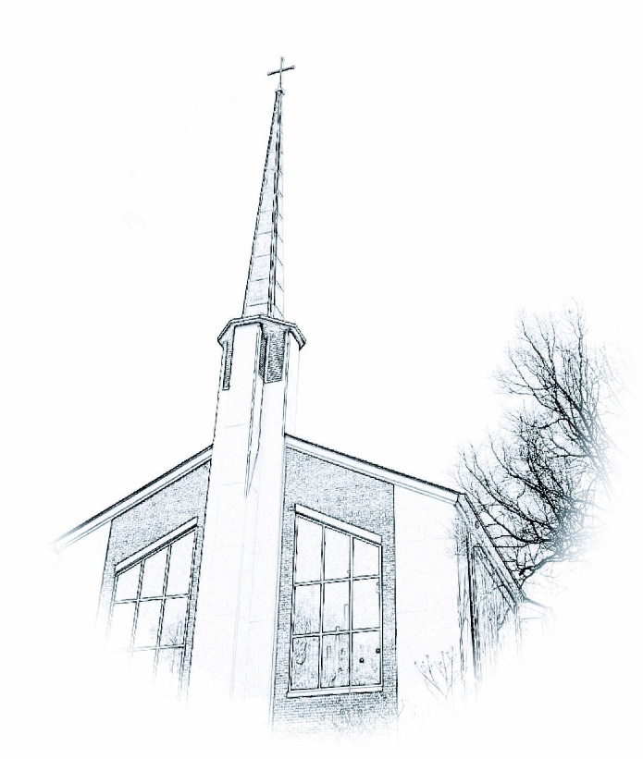

*Inviting people to life in Christ…*

*lived together…*

*for the sake of others.*