Transfiguration of the Lord
February 15, 2026

PRELUDE It is Well With My Soul
WELCOME TO WESTMINSTER Elder Leigh Moran
PRAYER OF INVOCATION
† CALL TO WORSHIP from Psalm 138
Leader: I will praise you, Lord, with all my heart; before the “gods” I will
sing your praise.
People: I will bow down toward your holy temple and will praise your
name for your unfailing love and your faithfulness.
Leader: When I called, you answered me; you greatly emboldened me.
People: May all the kings of the earth praise you, Lord, when they hear
what you have decreed.
Leader: May they sing of the ways of the Lord, for the glory of the Lord is
great.
People: Your love, Lord, endures forever— do not abandon the works of
your hands.
† HYMNS OF PRAISE Praise to the Lord, the Almighty (#8)
He Who Began A Good Work In You
SCRIPTURE READING Philippians 1:1-11
PRAYER OF CONFESSION
Eternal God, in whom we live and move and have our being, whose face is hidden from us by our sins, and whose mercy we forget in the blindness of our hearts: cleanse us from all our offenses, and deliver us from proud thoughts and vain desires, that with reverent and humble hearts we may draw near to you, confessing our faults, confiding in your grace, and finding in you our refuge and strength; through Jesus Christ your Son.
(Prayers of silent confession)
ASSURANCE OF FORGIVENESS

† DOXOLOGY
JUNIOR CHURCH
OFFERING
† HYMN OF PREPARATION Christ Our Hope in Life and Death
† SCRIPTURE READING Philippians 1:12-18
SERMON Finding Joy in Jail
Rev. Owen Stepp
Pastoral Prayer & tHE Lord’s Prayer
Our Father, who art in heaven, hallowed be thy name. Thy kingdom come; thy will be done on earth as it is in heaven. Give us this day our daily bread and forgive us our debts, as we forgive our debtors. Lead us not into temptation but deliver us from the evil one. For thine is the kingdom, and the power, and the glory, forever and ever. AMEN.
† AFFIRMATION OF FAITH Heidelberg Catechism
Q. #1 What is your only comfort in life and in death?

A. That I am not my own, but belong body and soul, in life and in death to my faithful Savior, Jesus Christ. He has fully paid for all my sins with his precious blood, and has set me free from the tyranny of the devil. He also watches over me in such a way that not a hair can fall from my head without the will of my Father in heaven; in fact, all things must work together for my salvation. Because I belong to him, Christ, by his Holy Spirit, assures me of eternal life and makes me wholeheartedly willing and ready from now on to live for him.
† HYMN OF RESPONSE It Is Well With My Soul (#493)
† BENEDICTION
POSTLUDE Praise to the Lord, the Almighty

Our Prayer Team will be available to pray with anyone in the Chapel following the service.

Welcome to Westminster Presbyterian Church
We are thankful you are here worshiping with us. We invite you to register your attendance with us today on the friendship pad found at the end of the pew.

Upcoming Events
Tonight – 5:30pm - Third Third Gathering -The vision is to engage, encourage and equip those entering the “third season” of life. (60+years). Brad Turnage will be speaking on A Steady Presence in Anxious Times.
Feb 17th -9:45am - Women's Morning Bible Study. Join us to study the theme of encouragement through Paul's letters.
Feb 18th – 5:30pm – Westminster Wednesday dinner. Join us for dinner and fellowship before the Ash Wednesday service at 6:30pm in the Sanctuary.
Feb 21st – 9:00am –Queen City Pregnancy Resource Center Service Project.
Feb 22nd – 5:00pm – Youth Group

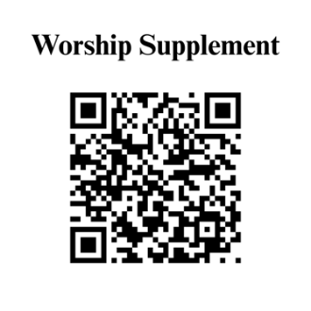

Find out more about Westminster by scanning the codes below with your phone’s camera:


101 Colville Road, Charlotte, NC 28207 | 704-376-0751 | westminstercharlotte.org

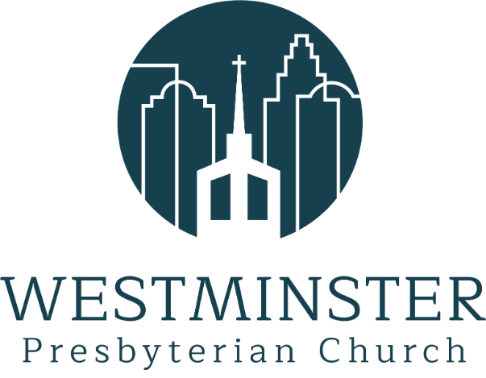

Inviting people to life in Christ…
lived together…
for the sake of others.

