Renewal of Baptism
January 4, 2026

PRELUDE
WELCOME TO WESTMINSTER Elder Nate Mitten
PRAYER OF INVOCATION
† CALL TO WORSHIP from Ephesians 4
Leader: Be completely humble and gentle; be patient, bearing with one
another in love.
People: Make every effort to keep the unity of the Spirit through the
bond of peace.
Leader: There is one body and one Spirit, just as you were called to one
hope when you were called;
People: One Lord, one faith, one baptism; one God and Father of
all, who is over all and through all and in all.
† HYMN OF PRAISE Christ Is Made the Sure Foundation (#276)
SCRIPTURE READING 1 Corinthians 12:12-20
PRAYER OF CONFESSION
Merciful God, in baptism you promise forgiveness and new life, making us part of the body of Christ. We confess that we remain preoccupied with ourselves, separated from you and one another. We cling to destructive habits, hold grudges, and show reluctance to welcome one another. We allow regret of the past and fear of the future to hold us captive. In your loving kindness, have mercy on us, and free us from sin. Fulfill the promises of our baptism so that we may rise to new life in Christ and live together in your grace. In Jesus’ name we ask this…
(Prayers of silent confession)
ASSURANCE OF FORGIVENESS
† DOXOLOGY
JUNIOR CHURCH
OFFERING
† SCRIPTURE READING John 3:22-30
SERMON More Jesus, Please
Rev. Owen Stepp
Pastoral Prayer & tHE Lord’s Prayer
Our Father, who art in heaven, hallowed be thy name. Thy kingdom come; thy will be done on earth as it is in heaven. Give us this day our daily bread and forgive us our debts, as we forgive our debtors. Lead us not into temptation but deliver us from the evil one. For thine is the kingdom, and the power, and the glory, forever and ever. AMEN.
† AFFIRMATION OF FAITH Apostles’ Creed

I believe in God the Father Almighty; Maker of heaven and earth.

And in Jesus Christ His only Son, our Lord; who was conceived by the Holy Ghost, born of the Virgin Mary, suffered under Pontius Pilate, was crucified, dead, and buried; he descended into hell; the third day he rose again from the dead; he ascended into heaven and sitteth on the right hand of God the Father Almighty; from thence he shall come to judge the quick and the dead.

I believe in the Holy Ghost, the holy catholic Church, the communion of saints, the forgiveness of sins, the resurrection of the body, and the life everlasting. AMEN.
RENEWAL OF BAPTISMAL VOWS AND The Lord’s Supper

Invitation
Words of Institution

Prayer of Thanksgiving

Communion Songs Behold the Lamb

Living Waters

We invite all who have put their faith in Christ and been baptized to come to the Lord’s Table. We believe that children should be instructed on the meaning of the sacrament prior to receiving the Supper. Whether you are receiving communion or not we invite everyone to come forward and receive a blessing from the pastors during this time.
† HYMN OF RESPONSE They'll Know We Are Christians by Our Love (#284)
† BENEDICTION
POSTLUDE
Our Prayer Team will be available to pray with anyone in the Chapel following the service.
Welcome to Westminster Presbyterian Church
We are thankful you are here worshiping with us. We invite you to register your attendance with us today on the friendship pad found at the end of the pew.

Upcoming Events
Jan 4th - 5:00pm - Youth Group on the Youth Floor.
Jan 8th - 2:00-6:30pm - American Red Cross Blood Drive in Beard Hall hosted by Smith Galvin and Charlotte Coffron.
Jan 9th - 6:45am - Men’s Breakfast - Join the men of the church for fellowship and breakfast.
Jan 11th - 12:15pm - Second Sunday Lunch - Join us for fellowship and food following the 11am service. Come hear the highlights of the Camino trip.
Jan 18th - 5:30pm - Third Third Gathering - The vision is to engage, encourage and equip those entering the “third season” of life. (60+years).
Jan 25th - 5:00pm - Youth Group on the Youth Floor.
Jan 27th - 9:45am - Women’s Morning Bible Study - Join us to study the theme of encouragement through Paul's letters.

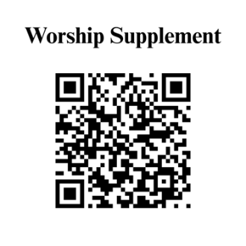

Find out more about Westminster by scanning the codes below with your phone’s camera:


101 Colville Road, Charlotte, NC 28207 | 704-376-0751 | westminstercharlotte.org

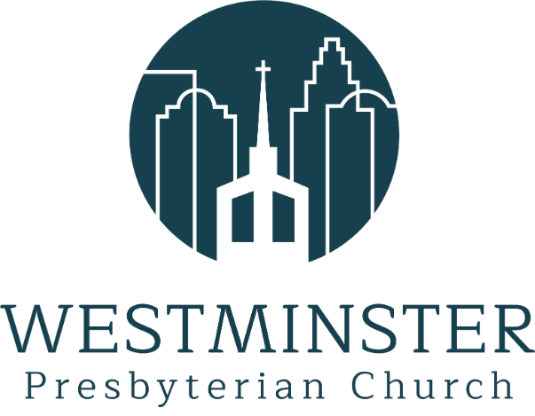

Inviting people to life in Christ…
lived together…
for the sake of others.

