Third Sunday in Lent
March 8, 2026

PRELUDE When I Survey the Wondrous Cross
WELCOME TO WESTMINSTER Elder Dennis Chen
PRAYER OF INVOCATION
† CALL TO WORSHIP from Psalm 95
Leader: O come, let us sing to the LORD; let us make a joyful noise to the rock of our salvation!
People: Let us come into his presence with thanksgiving; let us make a joyful noise to him with songs of praise!
Leader: For the LORD is a great God and a great King above all gods.
People: In his hand are the depths of the earth; the heights of the mountains are his also.
Leader: The sea is his, for he made it, and the dry land, which his hands have formed.
People: come, let us worship and bow down; let us kneel before the LORD, our Maker!
Leader: For he is our God, and we are the people of his pasture and the sheep of his hand.

† HYMNS OF PRAISE Christ Be Magnified
When I Survey the Wondrous Cross (#185)
SCRIPTURE READING Philippians 3:1-14
PRAYER OF CONFESSION
Almighty God, you have promised to provide everything that we need, and still we turn our eyes to lifeless idols. We pursue fortune and comfort. We pursue the empty glory of praise from other people. We are more confident in ourselves than we are in you. Turn us back to you and give us the confidence to look to you for our salvation. Forgive these and all of our sins, O Lord. Draw us, keep us, and renew us for the sake of your Son, Jesus Christ. (Prayers of silent confession)
ASSURANCE OF FORGIVENESS
† DOXOLOGY
YOUTH CONFIRMATION
† HYMN OF PREPARATION You Are My All in All
JUNIOR CHURCH
OFFERING
† SCRIPTURE READING Philippians 3:15-21
SERMON The Vote of No Confidence
Rev. Owen Stepp
Pastoral Prayer & tHE Lord’s Prayer
Our Father, who art in heaven, hallowed be thy name. Thy kingdom come; thy will be done on earth as it is in heaven. Give us this day our daily bread and forgive us our debts, as we forgive our debtors. Lead us not into temptation but deliver us from the evil one. For thine is the kingdom, and the power, and the glory, forever and ever. AMEN.
† AFFIRMATION OF FAITH From the Second Helvetic Confession
We openly profess and preach that Jesus Christ is the sole Redeemer and Savior of the world, the King and High Priest, the true and awaited Messiah, that holy and blessed one whom all the types of the law and predictions of the prophets prefigured and promised; and that God appointed him beforehand and sent him to us, so that we are not now to look for any other. Now there only remains for all of us to give all glory to Christ, believe in him, rest in him alone, despising and rejecting all other aids in life.
† HYMN OF RESPONSE Turn Your Eyes
† BENEDICTION
POSTLUDE How Firm a Foundation
Our Prayer Team will be available to pray with anyone in the Chapel following the service.

Welcome to Westminster Presbyterian Church
We are thankful you are here worshiping with us. We invite you to register your attendance with us today on the friendship pad found at the end of the pew.

Upcoming Events
Today – 12:15pm – Second Sunday Lunch – Join us for fellowship and food following the 11am service.
Today– 12:15pm – Welcome to Westminster –Join us to learn more about Westminster. If you are discerning whether to become a Covenant Partner or simply interested in learning more, you are welcome to come.
Tonight – 5:00pm – Youth Confirmation Celebration at Laura Parrott’s home. All youth are invited.
Mar 10th -9:45am - Women's Morning Bible Study. Join us to study the theme of encouragement through Paul's letters.
Mar 11th – 5:30pm – Westminster Wednesday dinner and program to discuss how the scriptures in Philippians intersect and integrate with our daily lives.

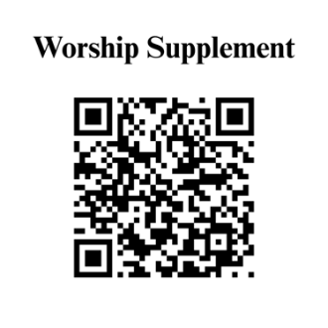

Find out more about Westminster by scanning the codes below with your phone’s camera:


101 Colville Road, Charlotte, NC 28207 | 704-376-0751 | westminstercharlotte.org

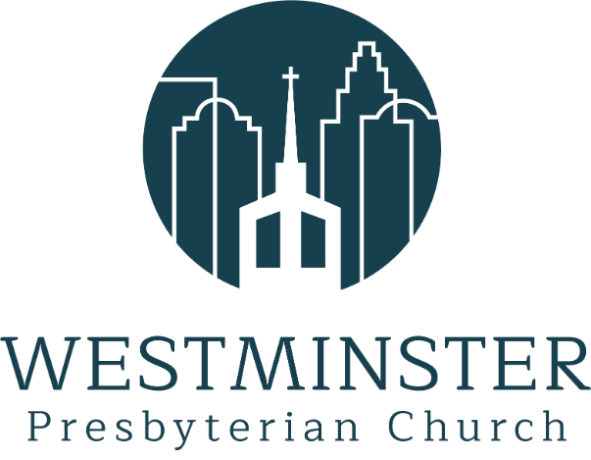

Inviting people to life in Christ…
lived together…
for the sake of others.

