Fourteenth Sunday after Pentecost
September 14, 2025

PRELUDE How Firm a Foundation
WELCOME TO WESTMINSTER Elder Stacy Cordes
PRAYER OF INVOCATION
† CALL TO WORSHIP from Psalm 121
Leader: I lift up my eyes to the hills. From where does my help come?
People: My help comes from the Lord, who made heaven and earth.
Leader: He will not let your foot be moved; he who keeps you will not
slumber.
People: Behold, he who keeps Israel will neither slumber nor sleep.
Leader: The Lord is your keeper.
People: The Lord is your shade on your right hand.
Leader: The Lord will keep your going out and your coming in from this time
forth and forevermore.
All: Let us worship the Living God together!
† HYMNS OF PRAISE How Firm a Foundation (#275)
Blessed Be Your Name

SCRIPTURE READING Hebrews 11:1-3,8-14
PRAYER OF CONFESSION
Faithful Father, we come to you this morning aware of our unfaithfulness in trusting you completely. We acknowledge that the cares of this life and the counterfeit gods of our world and our hearts hinder us from receiving the abundant life you so want to share with us. At times we try to earn your love. Father, forgive us for our striving. At other times we refuse your love. Father, forgive us for our pride. Teach us what it means to have faith in your sovereign goodness, trusting in your promise of righteousness as you re-make us into new creations. Hear us now as we unburden our hearts before your healing throne of grace...
(Prayers of silent confession)

ASSURANCE OF FORGIVENESS
† DOXOLOGY
JUNIOR CHURCH
OFFERING
† HYMN OF PREPARATION By Faith
SCRIPTURE READING Romans 4:13-25
SERMON What Is True Faith?
Rev. Dr. Leslie S. Dibble
Pastoral Prayer & tHE Lord’s Prayer
Our Father, who art in heaven, hallowed be thy name. Thy kingdom come; thy will be done on earth as it is in heaven. Give us this day our daily bread and forgive us our debts, as we forgive our debtors. Lead us not into temptation but deliver us from the evil one. For thine is the kingdom, and the power, and the glory, forever and ever. AMEN.
† AFFIRMATION OF FAITH Heidelberg Catechism
Q. #21 What is True Faith?
A. True faith is not only a sure knowledge by which I hold as true all that God has revealed to us in Scripture; it is also a wholehearted trust, which the Holy Spirit creates in me by the gospel, that God has freely granted, not only to others but to me also, forgiveness of sins, eternal righteousness, and salvation. These are gifts of sheer grace, granted solely by Christ’s merit.
† HYMN OF RESPONSE Be Thou My Vision (#382)
† BENEDICTION
POSTLUDE Fugue in C Major
Our Prayer Team will be available to pray with anyone in the Chapel following the service.

Welcome to Westminster Presbyterian Church
We are thankful you are here worshiping with us. We invite you to register your attendance with us today on the friendship pad found at the end of the pew.

Upcoming Events
September 14th - Second Sunday Lunch – Join us for fellowship right after the 11am service and hear about the highlights from the Scotland Mission Team.

September 21st – Third Third Gathering – The vision is to engage, encourage and equip those entering the “third season” of life. (60+years).

September 24th – Nov 5th – Westminster Wednesday Dinner & Program.
Join us for a video series “Practicing the Way with John Mark Comer.

Sept 28th – Sundays in Song – Taizé and Prayer – An evening gathering of music.

October 5th - Welcome to Westminster – Come join us to learn how Westminster understands itself as a body of Christ in ministry to our city, what is happening and how you can get engaged.

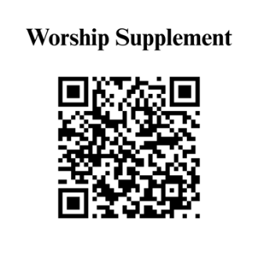

Find out more about Westminster by scanning the codes below with your phone’s camera:


101 Colville Road, Charlotte, NC 28207 | 704-376-0751 | westminstercharlotte.org

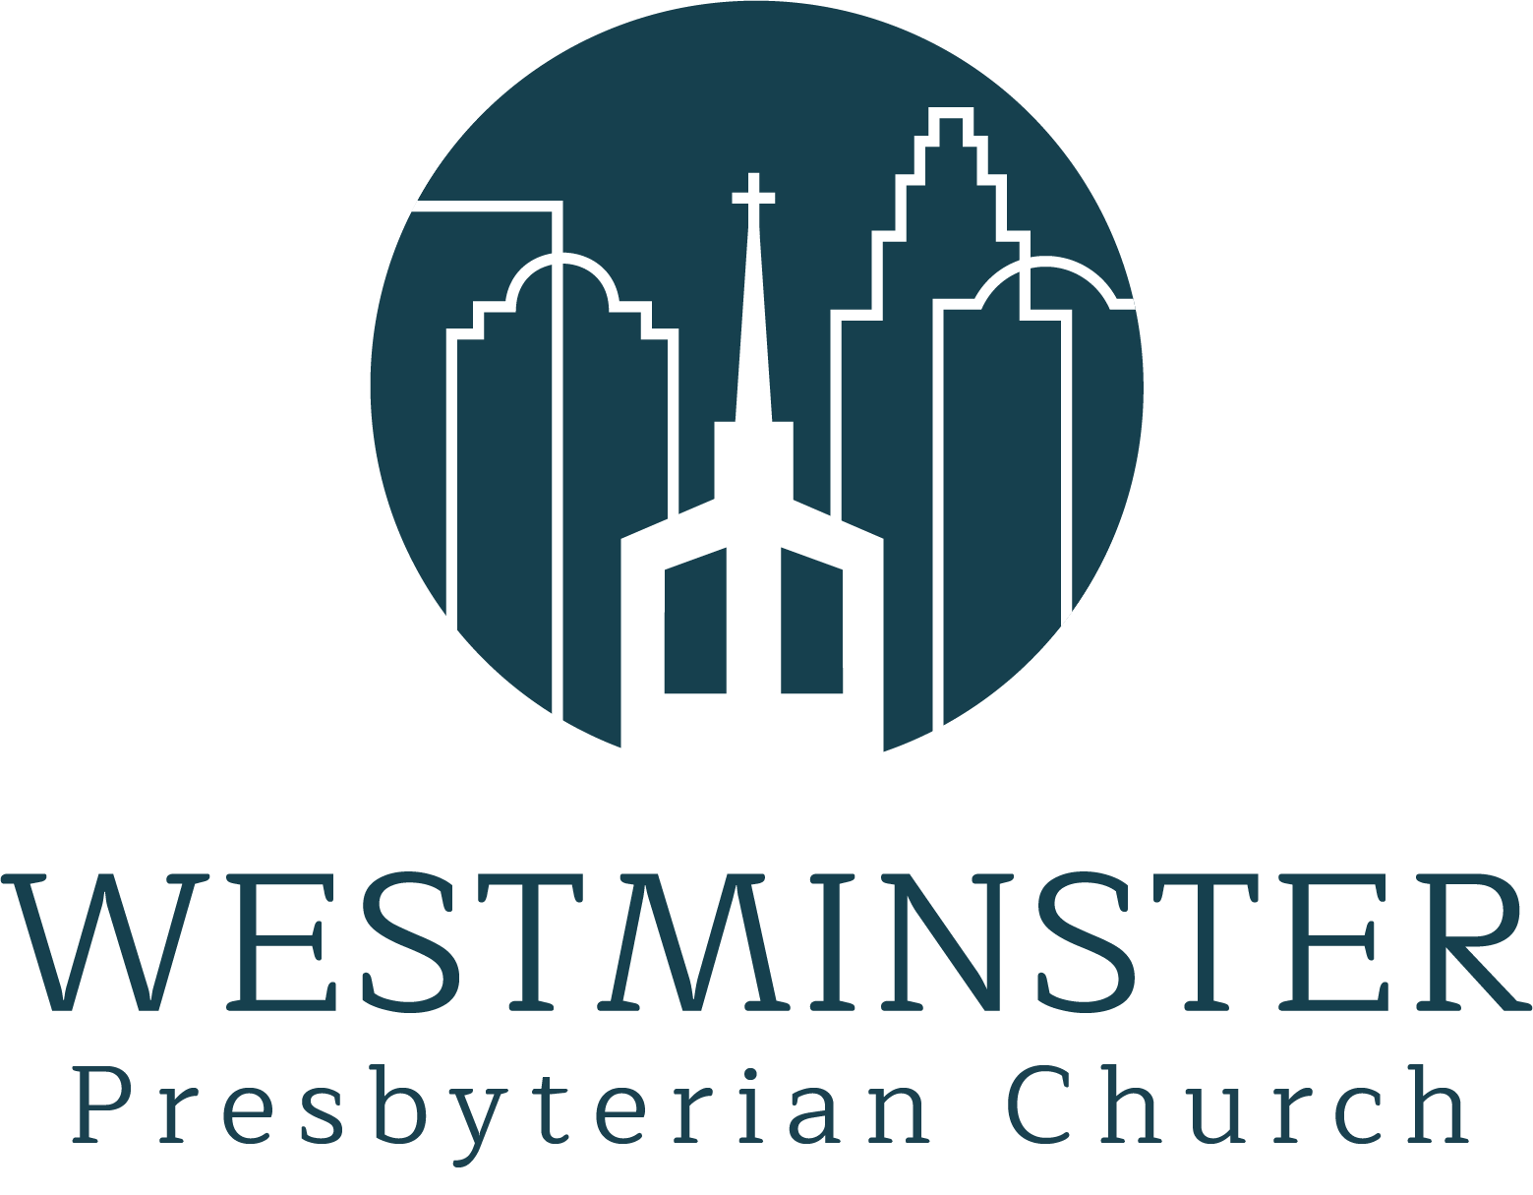

Inviting people to life in Christ…
lived together…
for the sake of others.

