Sixteenth Sunday after Pentecost
September 28, 2025

PRELUDE Love Divine, All Loves Excelling
WELCOME TO WESTMINSTER Elder Leigh Moran
PRAYER OF INVOCATION
† CALL TO WORSHIP
Leader: “I am the Alpha and the Omega,” says the Lord God,
People: “who is, and who was, and who is to come, the Almighty.”
Leader: Lord, you have been our dwelling place throughout all
generations.
People: Before the mountains were born,
Leader: Or You brought forth the earth and the world,
People: From everlasting to everlasting You are God.
Leader: Wait for the Lord;
People: Be strong and take heart and wait for the Lord.
† HYMNS OF PRAISE Blessed Jesus At Thy Word
Before the Throne of God Above
SCRIPTURE READING Revelation 4
PRAYER OF CONFESSION
Lord Jesus Christ, you call us to high standards, and we continuously fall short. You tell us to turn the other cheek and go the extra mile; to love our enemies and pray for those who persecute us. Not only do we fail to comply with these commands, we find them so outlandish that we don’t even try to live up to them. Forgive us for our failures and for our fatigue, for our stubbornness and for our sin. Hear us now as we continue to confess our sins in silence…
(Prayers of silent confession)

ASSURANCE OF FORGIVENESS

† DOXOLOGY
JUNIOR CHURCH
RECEPTION OF NEW COVENANT PARTNERS
Kyle and Kelly Nelson
OFFERING
Pastoral Prayer & tHE Lord’s Prayer
Our Father, who art in heaven, hallowed be thy name. Thy kingdom come; thy will be done on earth as it is in heaven. Give us this day our daily bread and forgive us our debts, as we forgive our debtors. Lead us not into temptation but deliver us from the evil one. For thine is the kingdom, and the power, and the glory, forever and ever. AMEN.
† HYMN OF PREPARTION All I Have Is Christ
SCRIPTURE READING Hebrews 4:14-5:4
SERMON Who Is Jesus?
Rev. Owen Stepp
† AFFIRMATION OF FAITH Heidelberg Catechism
Q. #31 Why is Jesus called “Christ” meaning “anointed”?
A. Because he has been ordained by God the Father and has been anointed with the Holy Spirit to be our chief prophet and teacher who fully reveals to us the secret counsel and will of God concerning our deliverance, our only high priest who has delivered us by the one sacrifice of his body, and who continually pleads our cause with the Father; and our eternal king who governs us by his Word and Spirit, and who guards us and keeps us in the freedom he has won for us.
† HYMN OF RESPONSE Alleluia! Sing to Jesus! (#233)
† BENEDICTION
POSTLUDE Settings of HYFRYDOL
Our Prayer Team will be available to pray with anyone in the Chapel following the service.

Welcome to Westminster Presbyterian Church
We are thankful you are here worshiping with us. We invite you to register your attendance with us today on the friendship pad found at the end of the pew.

Upcoming Events

Sept 24th – Nov 5th – Westminster Wednesday Dinner and program
featuring a video series “Practicing the Way” with John Mark Comer.

Sept 28th – LIFT – Leaning into Faith Together Lunch. Designed to encourage spiritual friendships that deepen our connection with God, each other, and our own faith journeys.

Sept 28th – Sundays in Song – Taizé and Prayer – An evening gathering of music and prayer.

Oct 5th – Blessings of the Animals.

Nov 16th - Welcome to Westminster – Join us to learn more about Westminster and how you can get connected.

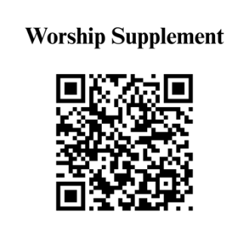

Find out more about Westminster by scanning the codes below with your phone’s camera:


101 Colville Road, Charlotte, NC 28207 | 704-376-0751 | westminstercharlotte.org

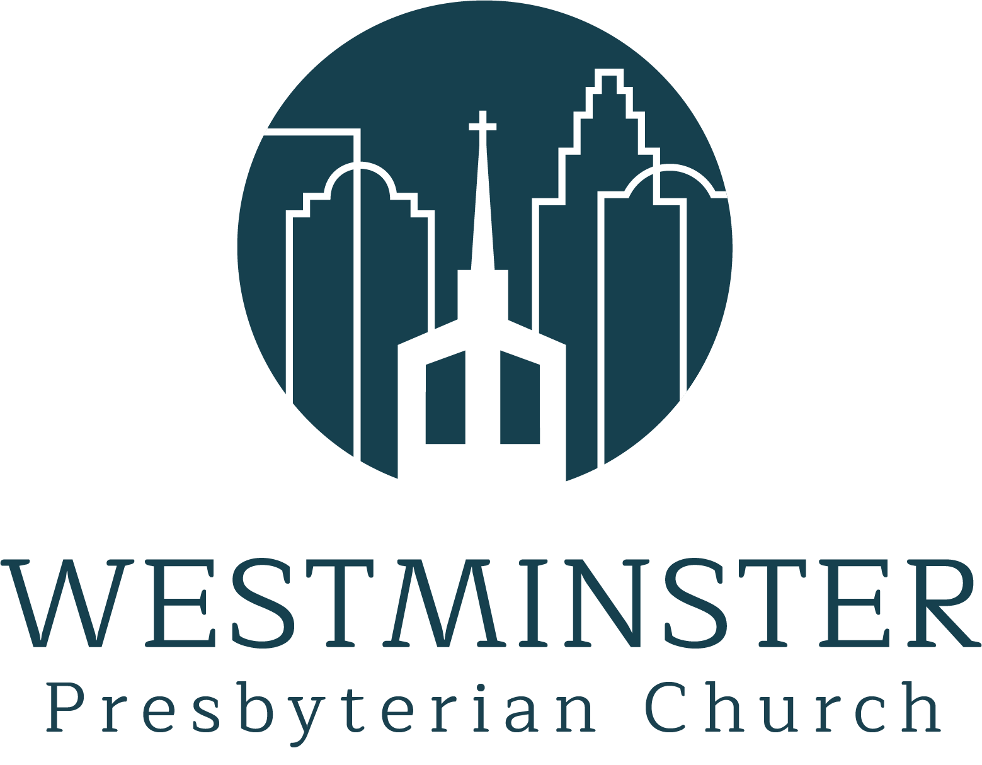

Inviting people to life in Christ…
lived together…
for the sake of others.

